**EECS3421 GROUP PROJECT**

**Final Report**

Case: [Cineplex](https://www.cineplex.com/) (9)

Course Section: B

Team Number: Group 9

|  |  |  |
| --- | --- | --- |
| **Student Name** | **Student ID** | **Email** |
| Mohammad Areeb | 220094736 | areeb157@my.yorku.ca |
| Prabhkrit Singh | 220164059 | krit@my.yorku.ca |
| Akash Deep | 220854162 | akash7@my.yorku.ca |
| Karthikeya Gorijavolu | 220241030 | gkarthik@my.yorku.ca |
| Samarjeet Singh Arora | 220857686 | samar15@my.yorku.ca |

**Introduction and Preliminary Study**

**The Organization**

Cineplex is an actual organization, which is amongst the most significant entertainment organizations in Canada itself as it operates several cinemas in the country, as well as offering entertainment services such as film screening facilities, VIP cinemas, game zones (Playdium), as well as event hosting for sports, concerts, etc. Cineplex also has an online platform where customers get to watch programming from the comfort of their homes. The firm was established in 1912, with headquarters based in Toronto, Ontario. For many years, this company has grown to be a market leader in the Canadian entertainment industry serving millions of clients every year via physical and digital services.

**Business Objective**

The primary objective of this database project is to design and implement a comprehensive relational database system that supports the core operations of a modern cinema theatre chain. This system addresses the critical business requirements of movie exhibition, ticket booking, concession sales, and customer loyalty management in an integrated digital platform.

The database aims to enable seamless end-to-end customer experiences by managing the complete lifecycle of movie-going activities, from browsing currently playing films and selecting showtimes to reserving seats, processing multi-method payments, ordering concessions, and participating in loyalty reward programs. By consolidating these diverse business functions into a unified data architecture, the system provides theatre operators with real-time inventory control, revenue tracking, and customer relationship management capabilities.

Key objectives include maintaining data integrity across concurrent booking operations through sophisticated seat locking mechanisms, supporting dynamic pricing strategies based on seat categories and membership benefits, facilitating complex payment workflows that combine credit cards, gift cards, and loyalty points, and providing comprehensive transaction history for both customers and theatre management. The database is designed to scale across multiple theatre locations while maintaining consistent business rules and operational standards.

**Scope of the Application**

1. Movies and metadata:

* Maintain movie records with title, synopsis, duration, language, release date, PG rating, and IMDB rating; attach posters/trailers via media files/URLs and upload timestamps.​
* Support many-to-many genres and cast members, including actor roles per movie for accurate discovery and crediting.​

2. Venues, screens, and seats:

* Model multiple theatres with address and contact details; each theatre houses multiple screens with capacity and premium features (VIP, D-Box flags).​
* Store individual seats with row/number and link to seat categories that carry accessibility flags and price modifiers.​

3. Showtimes and programming:

* Schedule showtimes per screen with date, start/end time, and 2D/3D indicator; enforce capacity via seat inventory.​
* Manage “currently playing” titles per theatre with run start/end and optional featured status.​

4. Reservations and seat locking:

* Allow users to begin checkout by temporarily locking selected seats; locks carry start/expiry times and auto-release to prevent double‑booking.​
* Capture per-seat pricing and status within a booking; booking tracks timestamp, status, and total.​

5. Bookings and unified payments:

* Support a single payment per booking that itemizes ticket subtotal, snack subtotal, tax, and total for auditability.​
* Enable mixed tenders: credit cards (with card type, postal, CVV, expiry), gift cards with balance transactions, and Scene+ point redemptions tied to the payment.​

6. Loyalty and memberships:

* Manage CineClub memberships with type, start/renewal and active status; issue member tickets with special pricing/terms.​
* Maintain Scene+ accounts with point balances and redemption history connected to payments for integrity.​

7. Concessions and orders:

* Store a snack catalog (items and combos) with availability and prices; record snack orders, items, quantities, and subtotals.​
* Process snack orders at the theatre level and present tickets and snacks together in a consolidated order summary for user history.​

8. Data integrity and rules:

* Enforce screen capacity through seat-level inventory; expire locks; validate membership active status; maintain gift card and points balances; and apply pricing via seat category modifiers.​
* Ensure all entities are linked to theatre/showtime context for traceability across locations.​

9. Out-of-scope items:

* Exclude staff/HR modules, third‑party gateway or loyalty API integrations, real-time concession stock management, analytics dashboards, and frontend/mobile UI; focus on data model, relational design, sample data, and SQL deliverables per the final report template.

**Functional Requirements**

1. Movie & Content Discovery:

Browse available movies, view details (title, synopsis, rating, cast, genres, runtime, language), and search by genre or showtime.

1. Theatre & Showtime Management:

Display theatres with locations and screens; schedule showtimes per screen with 2D/3D flags and available seat counts; manage currently playing titles with run dates and featured designation.

1. Seat Selection & Reservation:

Display seat maps by availability status; lock selected seats temporarily during checkout to prevent double-booking; apply seat-category pricing (regular, VIP, D-Box, accessible).

2. Booking & Checkout:

Create bookings with multiple seats; calculate total price (ticket subtotal + seat modifiers); track booking status from creation to confirmation.

1. Multi-Method Payment Processing:

Accept credit card, gift card, and Scene+ point redemptions in a single transaction; itemize ticket and snack subtotals with tax; generate payment records and receipts.

1. Loyalty & Membership:

Enroll users in Scene+ rewards program and CineClub membership; track point balances and redemption history; issue member-exclusive tickets and pricing.

1. Concessions Ordering:

Browse snack catalog (items, combos, prices); add items to order; calculate snack subtotal, process snack orders per theatre location.

1. User Account Management:

Register and maintain user profiles (personal info, contact details, payment methods); store gift card and loyalty card associations; track order history.

1. Reporting & Admin Functions:

Generate seat occupancy reports by showtime; summarize ticket and snack sales; track payment method usage and loyalty program engagement.

**Database Modelling**

**External Views**

This is a step-by-step **Moviegoer** journey, showcasing the use of database.

1. **Account Creation / Registration**
   * Navigate to registration/login screen.
   * Input name, contact info, and password.
   * Two-factor authentication (2FA) has been excluded for simplification purposes.
   * Confirm registration and access user dashboard.

Users can create an account here:

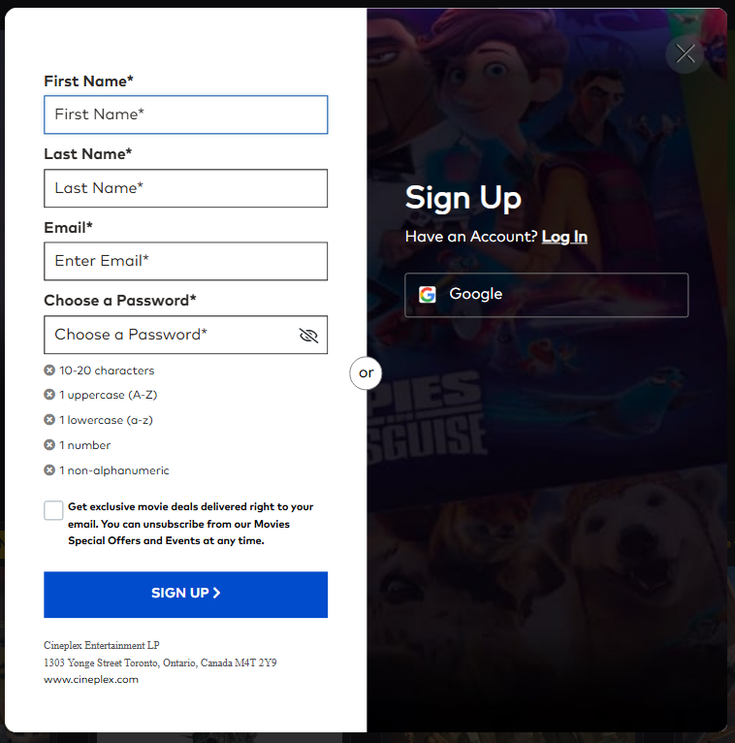

Users who already have an account can login here:

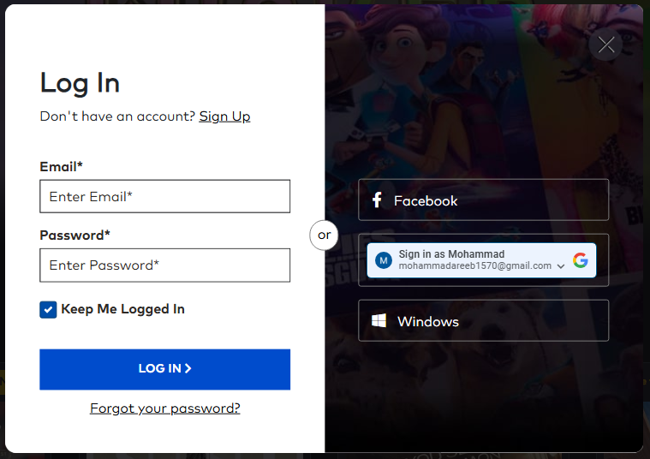

Link Credit Cards/Gift Cards (Optional)

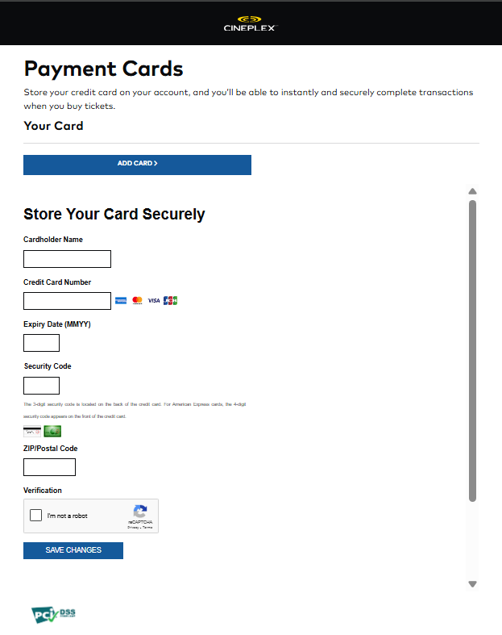

After Registration Users can access the account dashboard

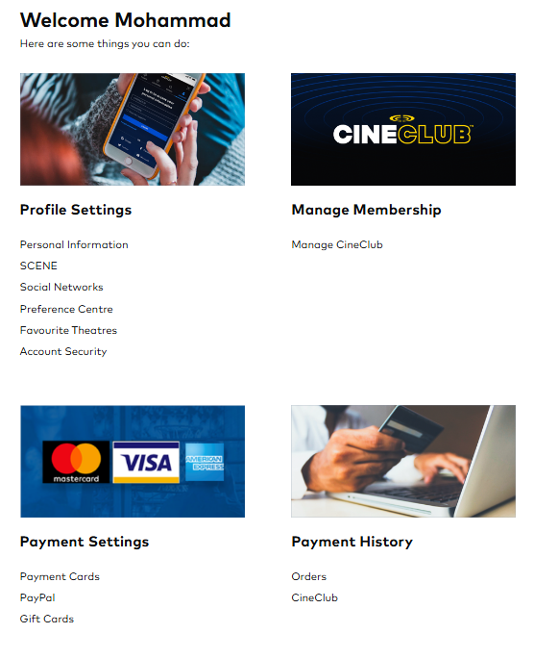

1. **Browse Cinemas and Movies**
   * Select theatre location or search by city.
   * View list of currently playing movies.
   * Click on a movie for details (synopsis, cast, genre, rating).
   * Browse trailers and posters.

User landing page

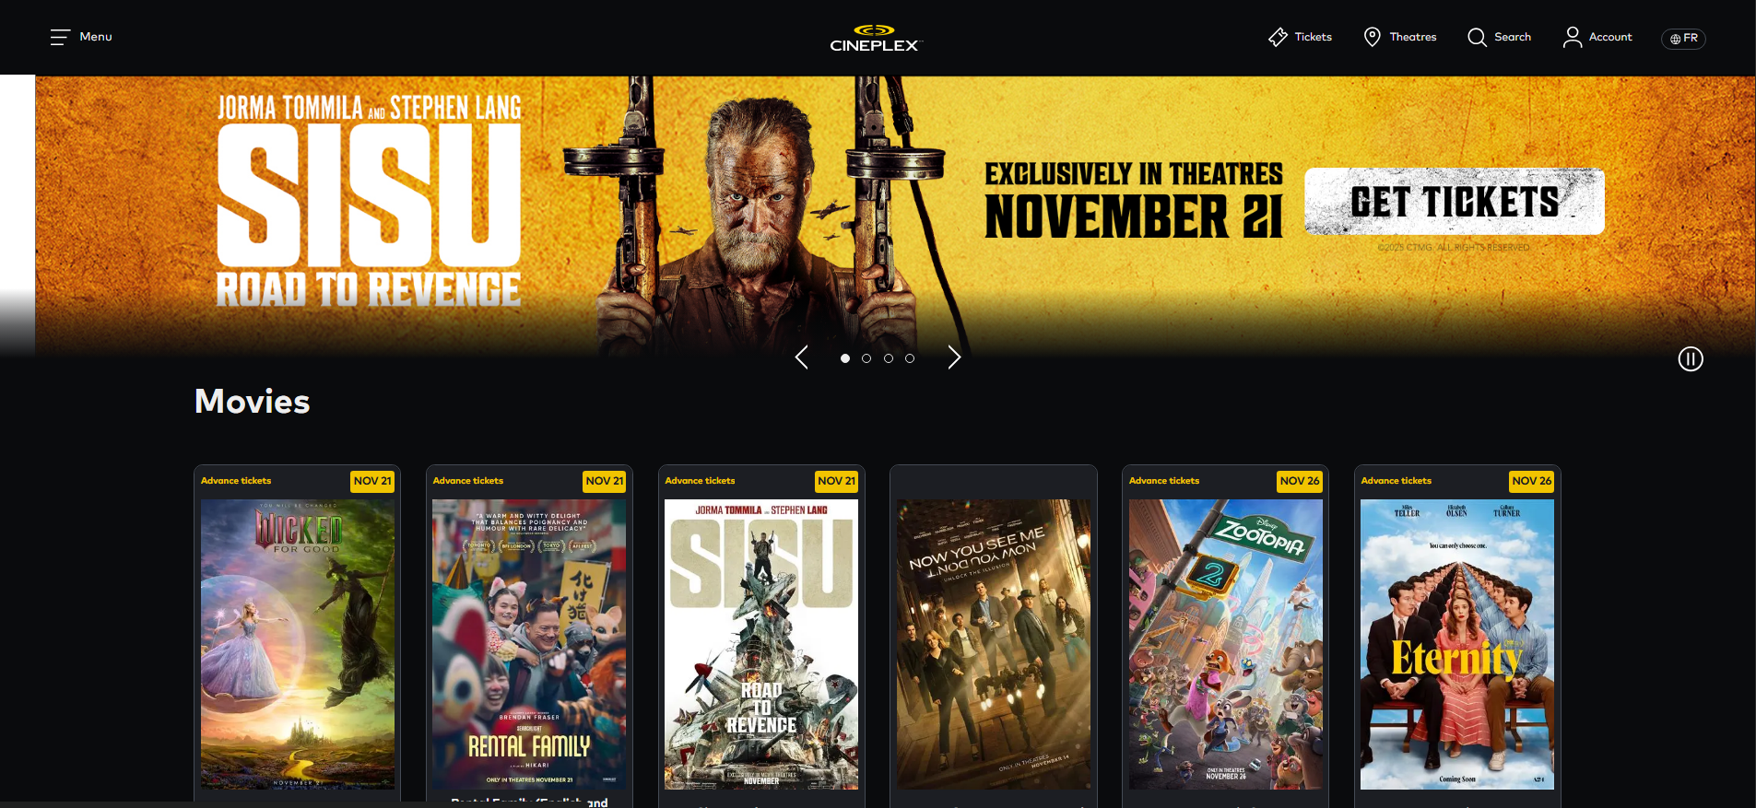

Select theatre location or city

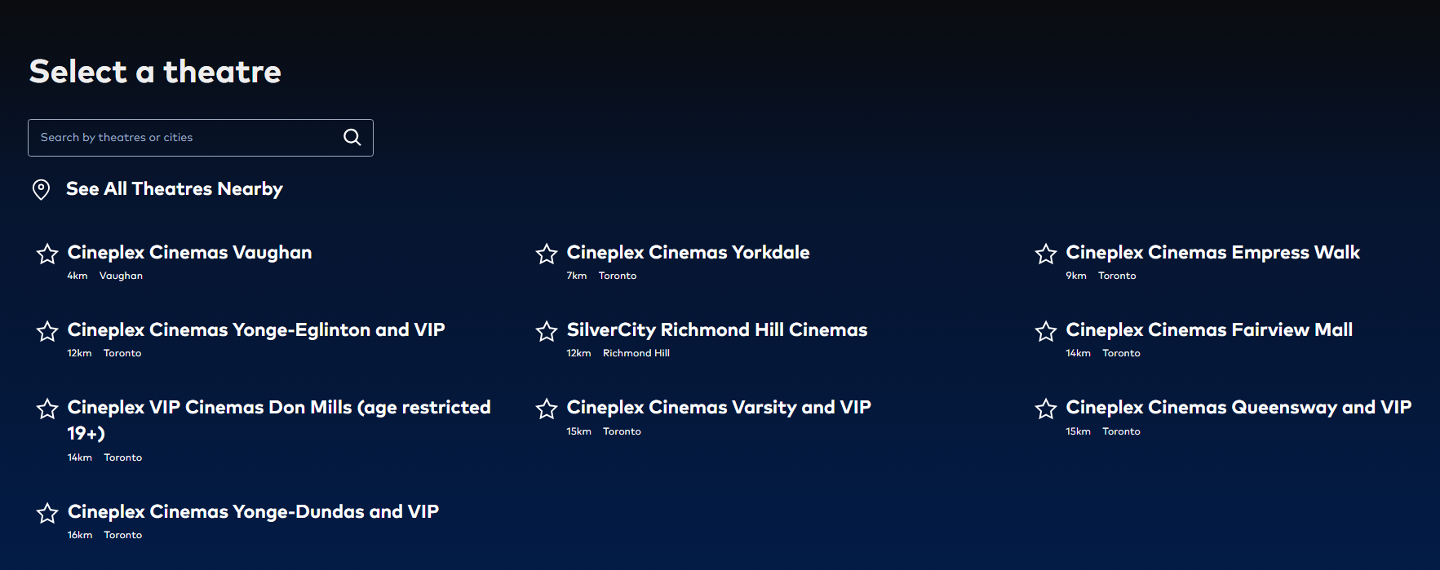

View a list of currently playing movies

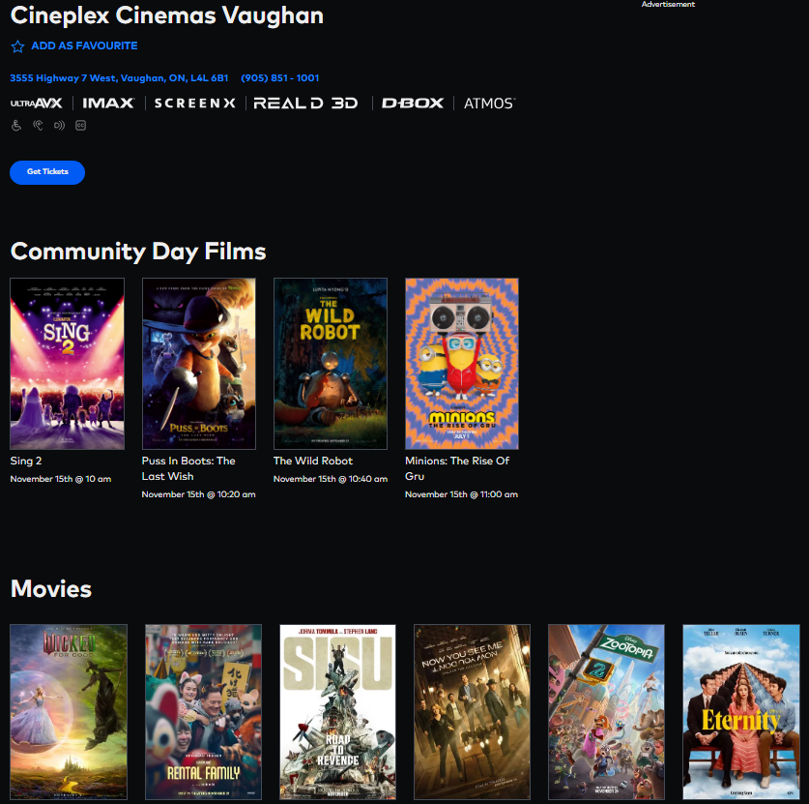

Select a movie for details and browse trailers/posters

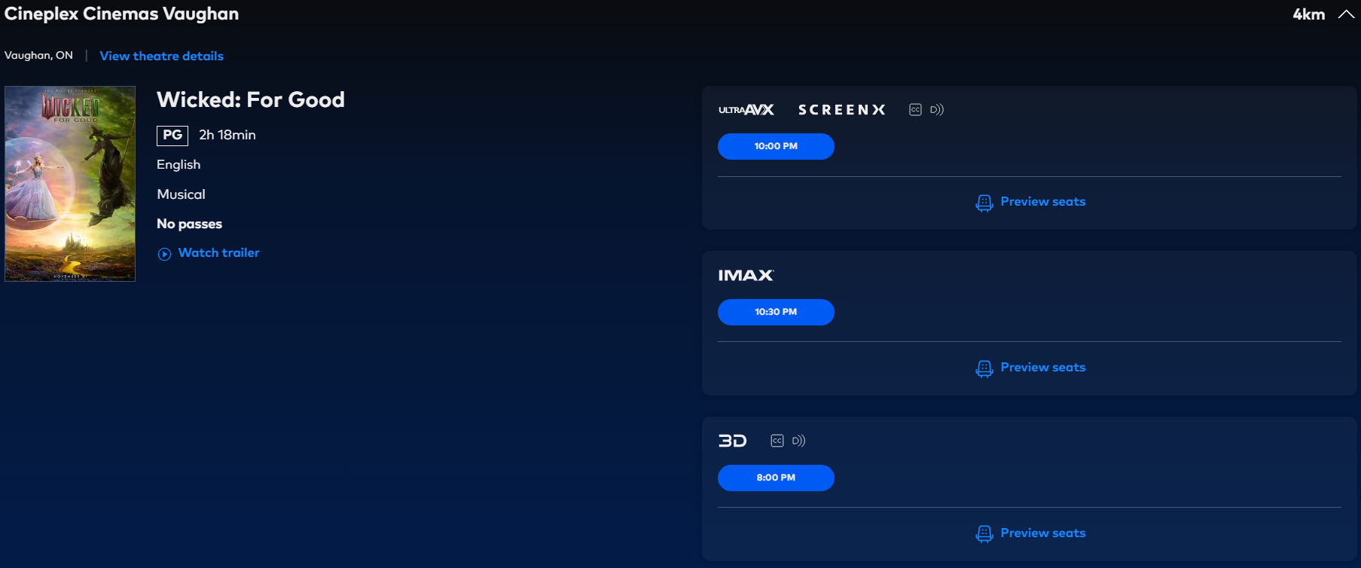

1. **Choose Screening and View Seats**
   * Select a showtime and hall for the chosen movie.
   * View the seat map, displaying occupied/reserved seats.
   * Seat categories and badges are visible.

Selecting a show

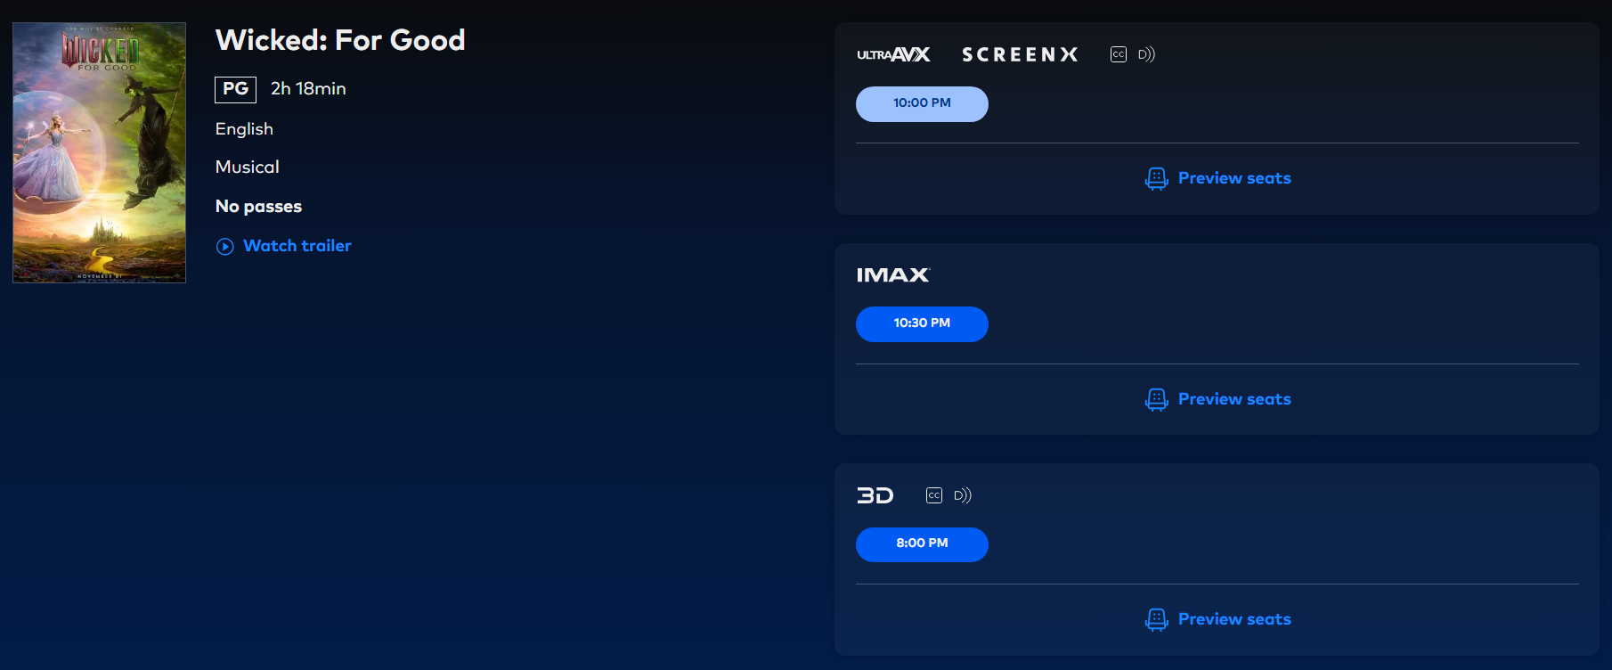

View the seat map, along with categories/badges

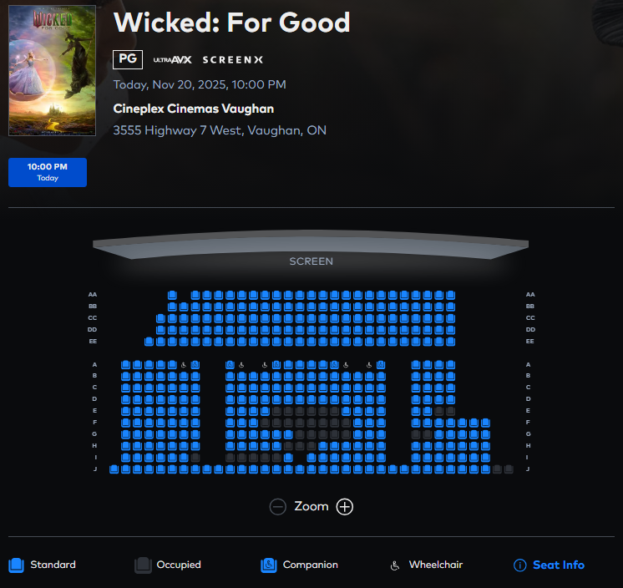

1. **Select Seats and Tickets**
   * Select the desired number and type of seats.
   * The seat lock is placed.
   * View the seat map and select desired seat location.

After selecting the show, select tickets

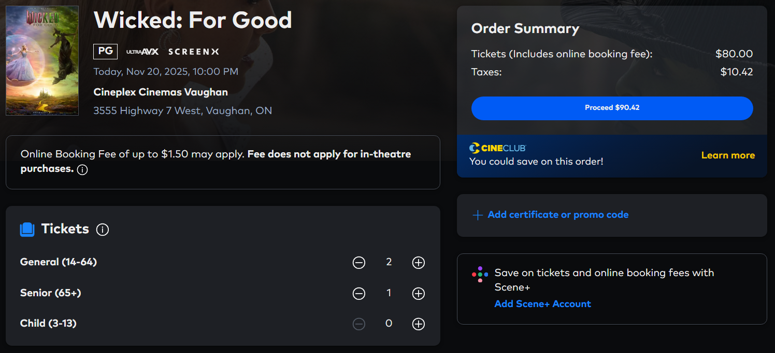

View the seat map and reservations

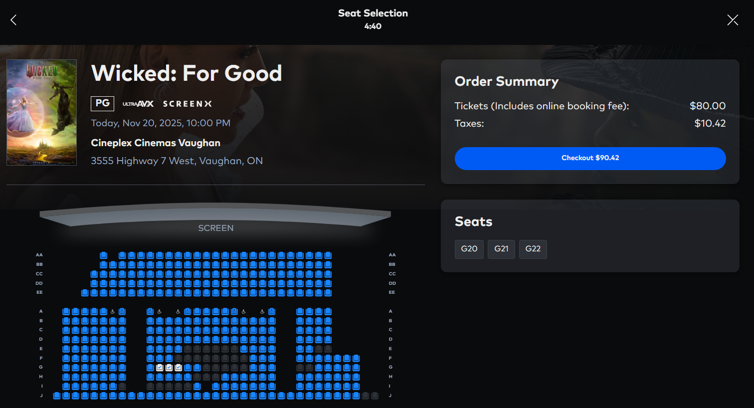

The seat lock prevents double reservation



D-Box-enabled movies include D-Box ticket selections alongside standard options

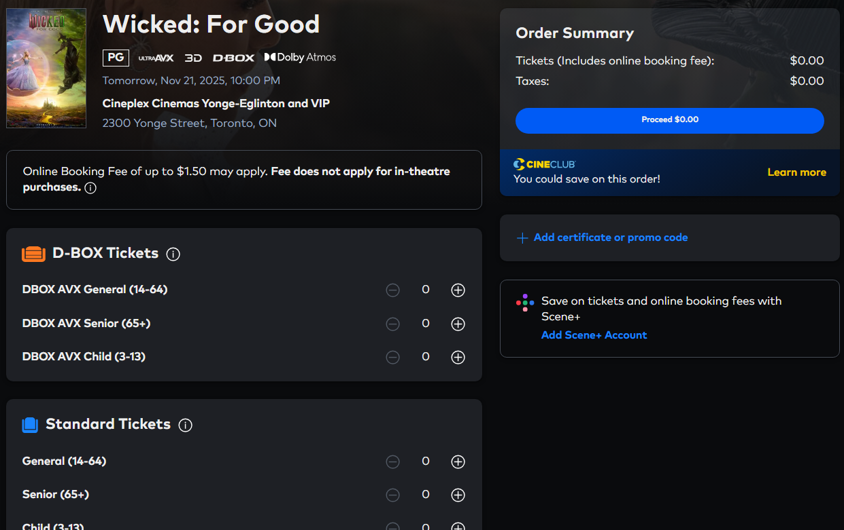

1. **Add Snacks (Optional)**
   * Cineplex users can also browse and order snacks tied to the selected theatre
   * Items are structured into categories and priced per unit
   * Orders can include multiple items with custom quantities

Select a theatre

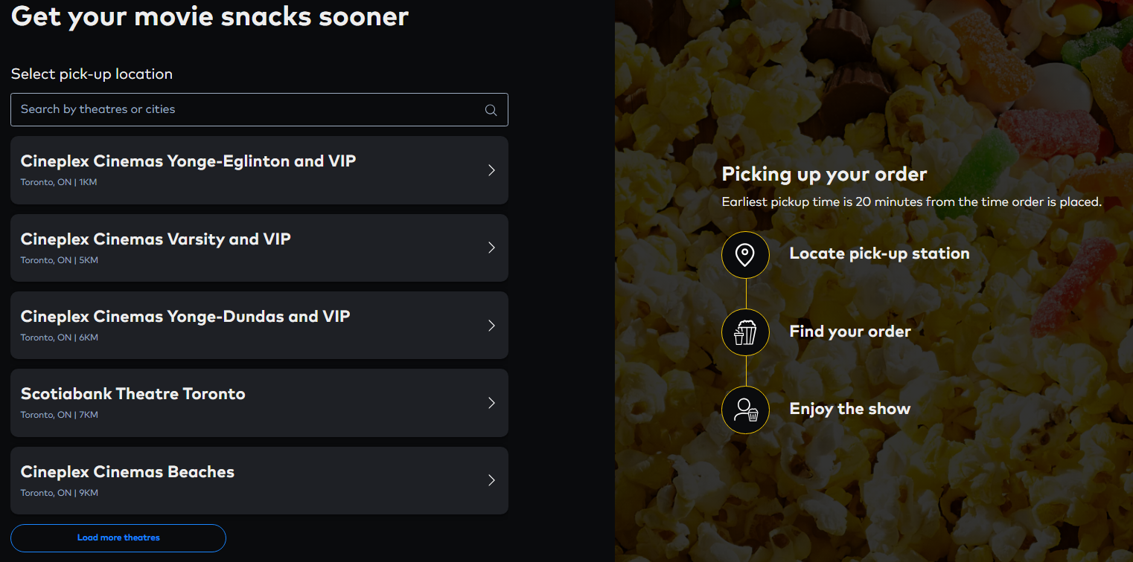

A wide selection of combos & snacks to choose from

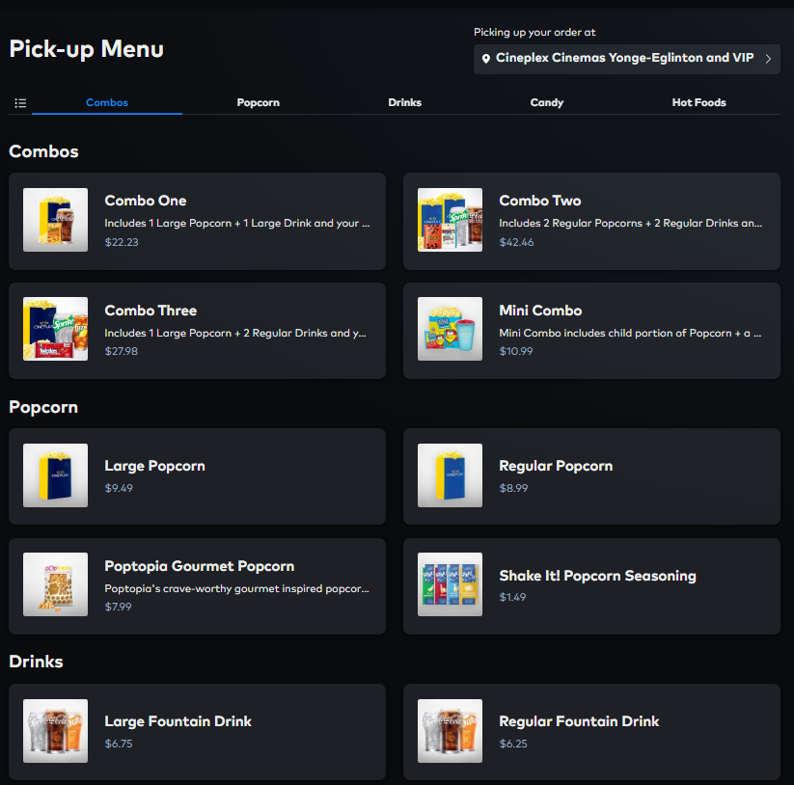

Add snacks to your cart, which will be stored in the database

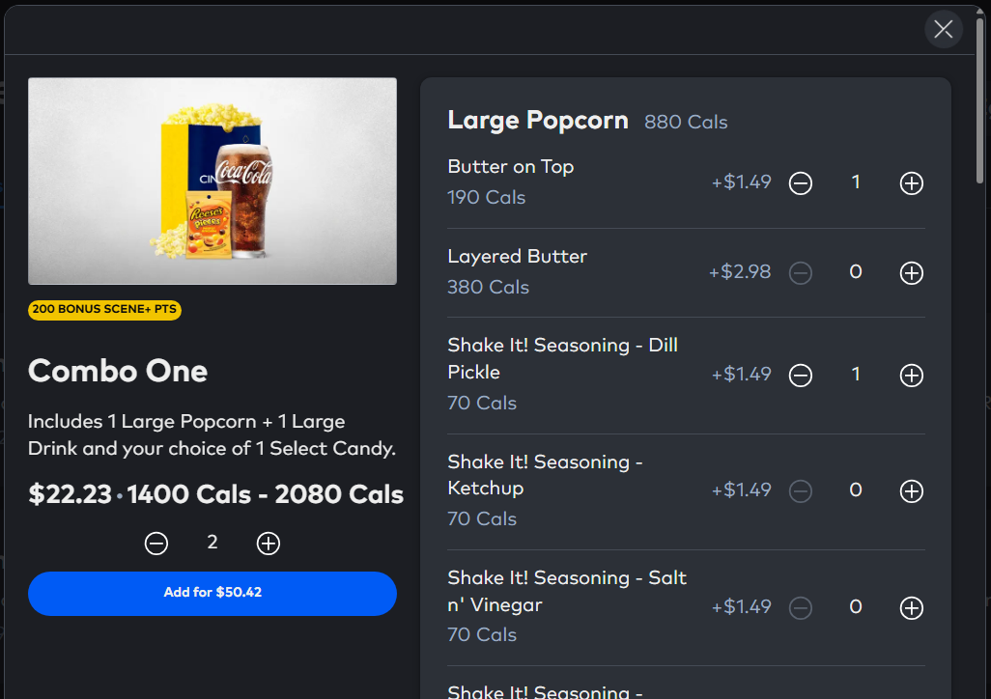

1. **Apply Offers and Pay**
   * Review cart: tickets, snacks, subtotal, tax, and total.
   * Apply CineClub ticket, ScenePlus points, or gift card.
   * Enter or select payment method (credit card, etc.).
   * Submit payment and receive confirmation.

Review the snack cart

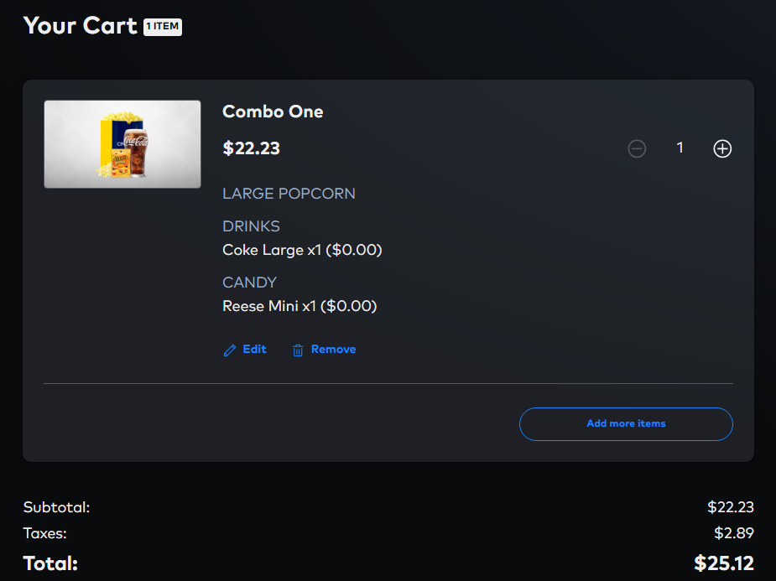

Apply gift cards/CineClub or select payment method

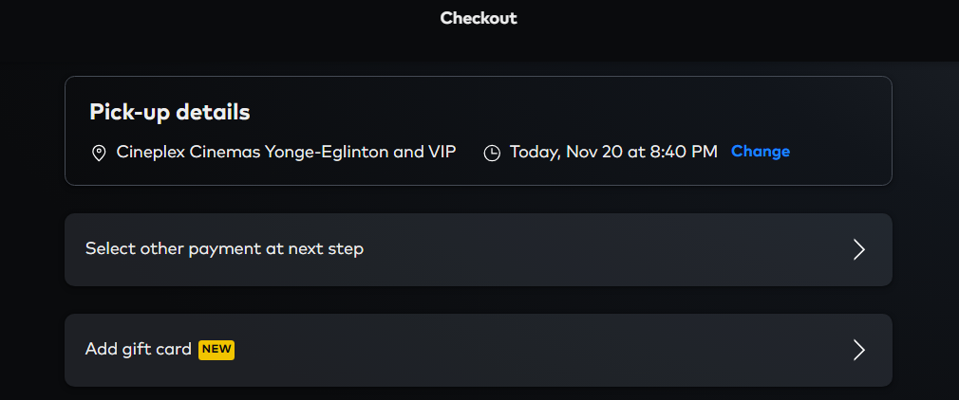

Review the tickets cart/Add gift cards

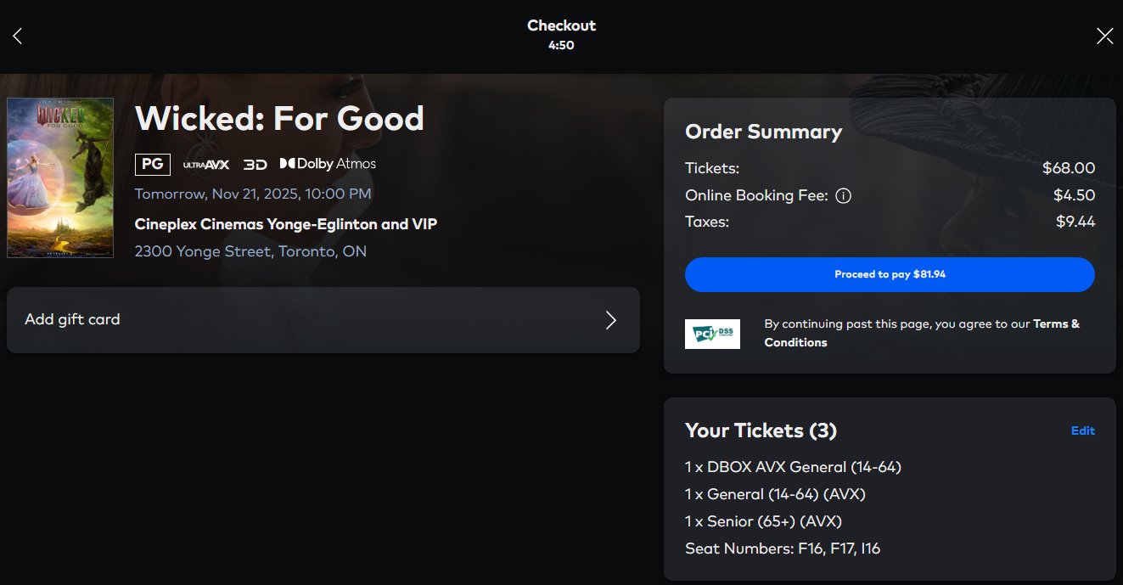

Procced to payment with Credit Card

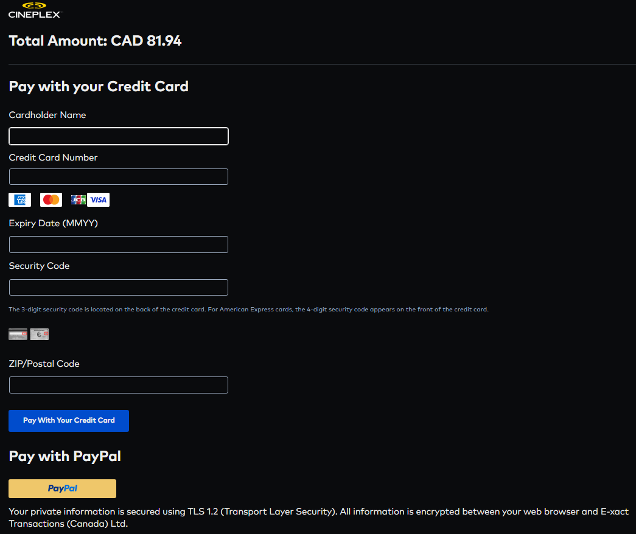

1. **Confirmation and History**

* Once payment succeeds, an OrderSummary is generated.
* This receipt captures the full breakdown of tickets, snack items, and applied discounts.
* Users can view their past orders in their account.

User can see previous reservations and order summary



**Other External Views as such:**

1. **Staff / Box Office**
   1. Find Showtimes and Seats
      * Search for screening by movie, hall, or date.
      * View real-time seat availability and locks.
   2. Book/Edit on Behalf of Customer
      * Select seats and create new booking.
      * Modify or cancel existing bookings.
   3. Accept Multiple Payments
      * Process payments by credit card, gift card, or loyalty points.
      * Issue and print booking receipt.
2. **Concessions Staff**
   1. View Snack Inventory
      * Access snack list and combo options by location.
      * View prices and current availability.
   2. Fulfill Snack Orders
      * Review pending snack orders with quantities.
      * Mark items as fulfilled and confirm payment.
3. **Manager / Corporate**
   1. Screening Oversight
      * Monitor active movies and showtime schedules by location.
      * Review seat occupancy reports for each hall.
   2. Review Sales & Loyalty Engagement
      * Generate reports for ticket and snack sales totals.
      * Track loyalty membership and redemption activity.

**Key Functionalities of the System**

|  |  |
| --- | --- |
| Functions | Description |
| Movie Ticket Booking | Book tickets for any showtime in any theatre |
| Snack Ordering | Order food/drink items tied to theatre location |
| Real-Time Seat Selection | See live seat maps; temporary locks to prevent conflicts |
| Order Summary Generation | Unified view of completed bookings and orders |
| Secure Payment Processing | Support for credit card, gift card, and SCENE+ redemptions |
| Loyalty Programs | CineClub and SCENE+ programs fully integrated |
| User Account Management | One account per email; must register to access system |
| Movie Catalog | Browse films with posters, trailers, cast, and  genres |

**Business Rules & Assumptions**

**Business Rules**

* User accounts are mandatory for all transactions, no guest or anonymous checkout.
* Seat locking prevents double-booking, locks expire automatically after 10 minutes, freeing seats for other users.
* Seat pricing is dynamic, calculated as base Screening price plus SeatCategory modifiers.
* One active booking per user per screening, users cannot book the same screening twice simultaneously.
* Payments support multiple concurrent methods, credit card, gift card balance deduction, and Scene Plus point redemption, within a single transaction.
* Each user can hold at most one active CineClub Membership and many ScenePlus Card at any time.
* All transactions generate immutable receipts, no post-payment refunds, cancellations, or transaction reversals are supported.
* Snack orders are fulfilled at the Complex level where they were placed.
* Movies can belong to multiple genres, cast members can appear in multiple movies.
* Currently playing status is managed per Complex, with featured designation and run date tracking.

**Assumptions**

1. Seat capacity is enforced at the Hall level with a fixed, unchangeable layout.
2. Snack availability is binary (available/unavailable), real-time inventory depletion is not tracked.
3. Payment records are created separately if a user purchases both tickets and snacks in one checkout.
4. Group bookings are not supported. Each Booking belongs to exactly one User.
5. Card data is encrypted/tokenized in production, prototype stores plaintext for demonstration.
6. Derived attributes (lock expiry, renewal dates, tax, total paid) are calculated automatically by the system.

**The E-R Data Model**

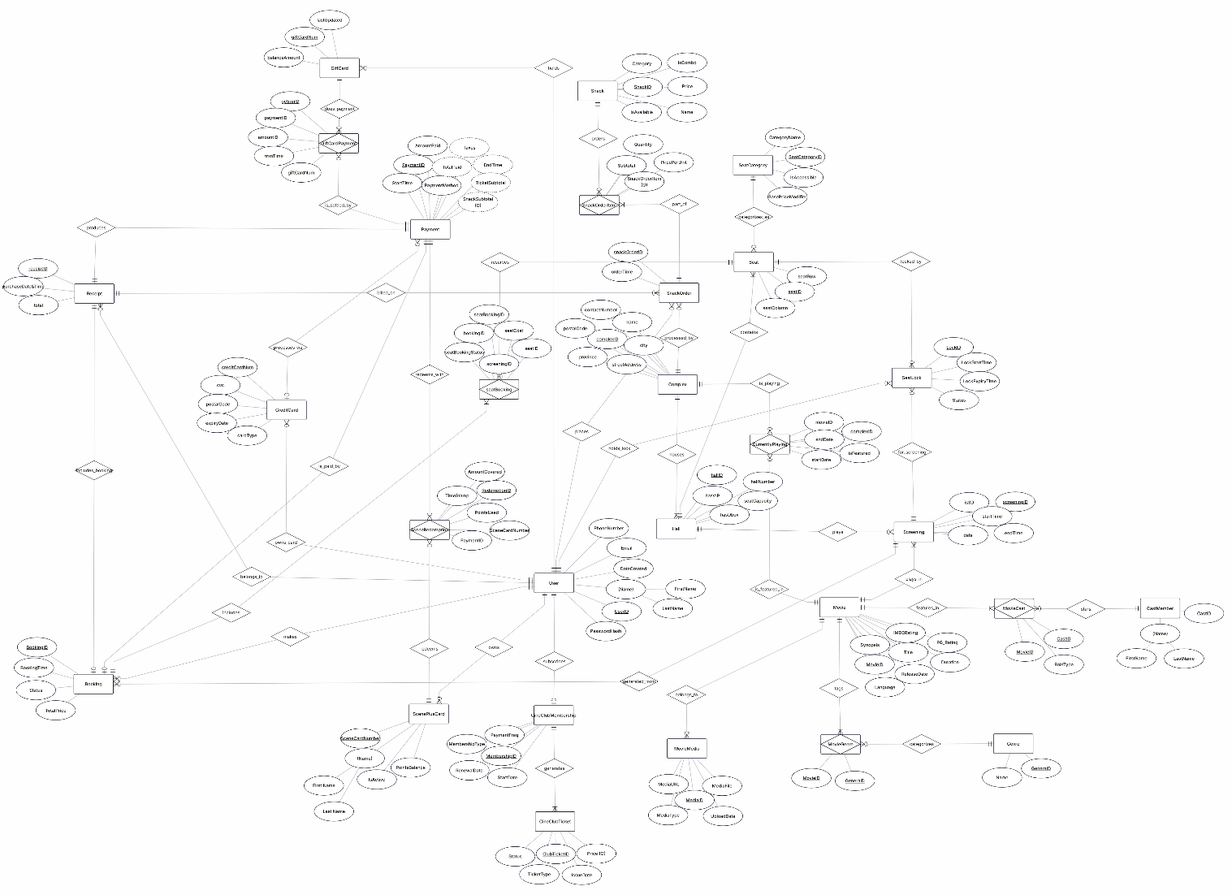

[Click here to access the High-Definition E-R model.](https://drive.google.com/drive/folders/1GXjMvtWV2Fs-1gmVfR1br3C4FOqhxptZ?usp=sharing)

**Logical design of the Relational Database**

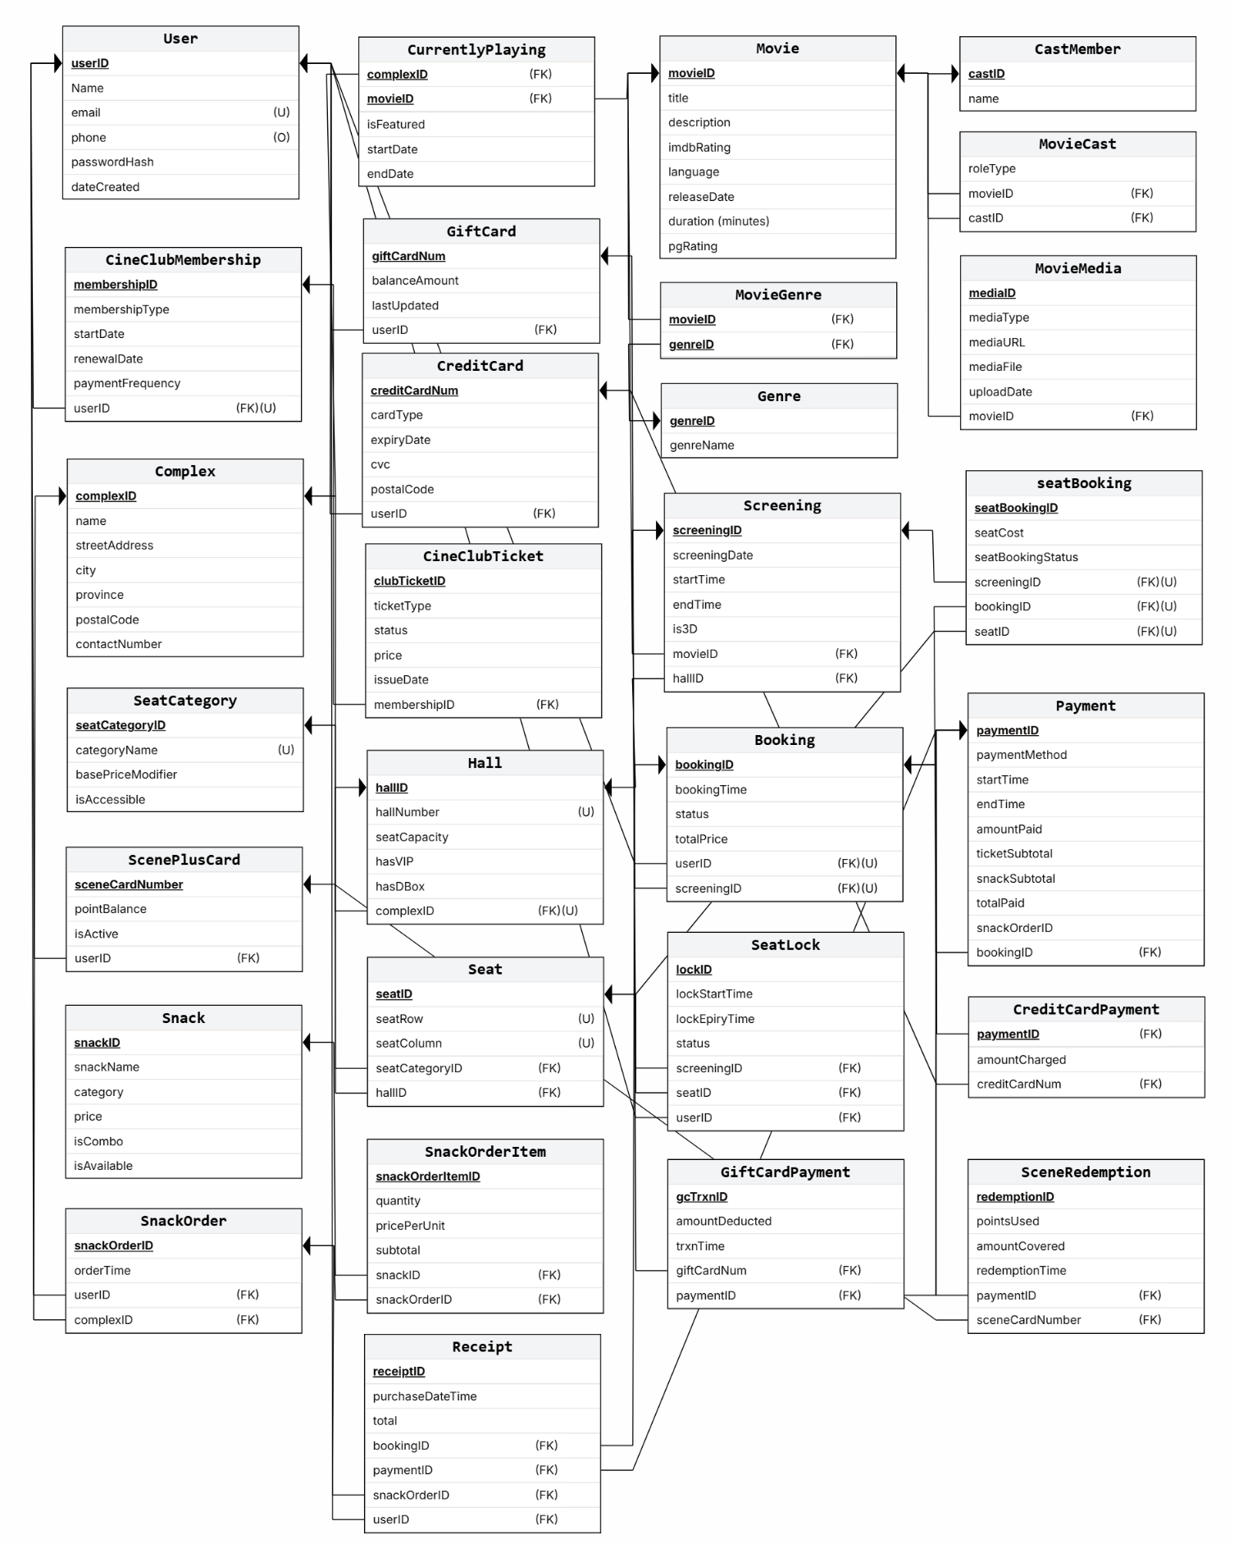

**Database design and implementation**

**Table design and data integrity control:**

1. **User**

(UserID, Name, Email, PhoneNumber, PasswordHash, DateCreated)

Primary Key: UserID

Unique: Email

Domain Constraints:

* Email must be valid format
* PhoneNumber optional
* PasswordHash non-null
* DateCreated auto-timestamp

**Normalization: 3NF** - All attributes are atomic, depend on PK only.

1. **CreditCard**

(CreditCardNum, CardType, ExpiryDate, CVC, PostalCode)

Primary Key: CreditCardNum

Foreign Key: None (implicit link via Payment)

Domain Constraints:

* CreditCardNum 16 digits (encrypted storage)
* CVC 3-4 digits
* ExpiryDate MM/YY format, must be future date
* CardType: Visa, Mastercard, Amex
* PostalCode alphanumeric

**Normalization: 3NF** - All attributes atomic, non-key attributes depend only on PK.

1. **ScenePlusCard**

(SceneCardNumber, PointsBalance, IsActive)

Primary Key: SceneCardNumber

Foreign Key: UserID (via User relationship)

Domain Constraints:

* SceneCardNumber unique, alphanumeric
* PointsBalance >= 0, default 0
* IsActive boolean, default True

**Normalization: 3NF** - non-key attributes depend directly on SceneCardNumber.

1. **GiftCard**

(GiftCardNum, BalanceAmount, LastUpdated)

Primary Key: GiftCardNum

Domain Constraints:

* GiftCardNum unique, 16 digits
* BalanceAmount >= 0 (currency)
* LastUpdated auto-timestamp on each transaction

**Normalization: 3NF** - All attributes atomic and depend on PK.

1. **CineClubMembership**

(MembershipID, UserID, MembershipType, StartDate, RenewalDate, PaymentFrequency)

Primary Key: MembershipID

Foreign Key: UserID -> User(UserID)

Unique: UserID (one membership per user)

Domain Constraints:

* MembershipType: Standard, Premium, VIP
* StartDate <= RenewalDate
* PaymentFrequency: Monthly, Annual
* RenewalDate derived/calculated from StartDate + frequency

**Normalization: 3NF** - non-key attributes depend only on MembershipID; no transitive dependencies.

1. **CineClubTicket**

(ClubTicketID, MembershipID, TicketType, Status, Price, IssueDate)

Primary Key: ClubTicketID

Foreign Key: MembershipID -> CineClubMembership(MembershipID)

Domain Constraints:

* TicketType: Complimentary, Discounted, Premium
* Status: Active, Redeemed, Expired
* Price >= 0
* IssueDate auto-timestamp

**Normalization: 3NF** - All non-key attributes depend on ClubTicketID only**.**

1. **Complex**

(ComplexID, Name, StreetAddress, City, Province, PostalCode, ContactNumber)

Primary Key: ComplexID

Domain Constraints:

* Name unique within city/province
* StreetAddress non-null
* PostalCode alphanumeric
* ContactNumber format validated

Normalization: 3NF - All attributes atomic; each describes a unique theatre location.

1. **Hall**

(HallID, ComplexID, HallNumber, SeatCapacity, HasVIP, HasDBox)

Primary Key: HallID

Foreign Key: ComplexID -> Complex(ComplexID)

Unique: (ComplexID, HallNumber)

Domain Constraints:

* SeatCapacity > 0
* HasVIP, HasDBox boolean

**Normalization: 3NF** - non-key attributes depend on HallID; ComplexID is FK (not transitive)**.**

1. **SeatCategory**

(SeatCategoryID, CategoryName, BasePriceModifier, IsAccessible)

Primary Key: SeatCategoryID

Unique: CategoryName

Domain Constraints:

* BasePriceModifier decimal (e.g., 1.0 for standard, 1.5 for VIP)
* IsAccessible boolean

**Normalization: 3NF** - All attributes atomic and depend on SeatCategoryID only.

1. **Seat**

(SeatID, HallID, SeatRow, SeatColumn, SeatCategoryID)

Primary Key: SeatID

Foreign Keys:

* HallID -> Hall(HallID)
* SeatCategoryID -> SeatCategory(SeatCategoryID)

Unique: (HallID, SeatRow, SeatColumn)

Domain Constraints:

* SeatRow alphanumeric (A, B, C, ...)
* SeatColumn numeric (1, 2, 3, ...)

**Normalization: 3NF** - non-key attributes (SeatRow, SeatColumn, SeatCategoryID) depend on Seat only; FKs not transitive.

1. **Movie**

(MovieID, Title, Synopsis, IMDBRating, Language, ReleaseDate, Duration, PG_Rating)

Primary Key: MovieID

Domain Constraints:

* Title non-null
* IMDBRating 0.0-10.0
* Language ISO 639-1 code (en, fr, etc.)
* Duration in minutes, > 0
* PG_Rating: G, PG, 12A, 15, 18, etc.

**Normalization: 3NF** - All attributes atomic, depend on MovieID only.

1. **Genre**

((GenreID, GenreName)

Primary Key: GenreID

Unique: GenreName

Domain Constraints:

* GenreName non-null

**Normalization: 3NF** - All attributes atomic and directly dependent on GenreID.

1. **MovieGenre (Associative)**

(MovieID, GenreID)

Primary Key: (MovieID, GenreID)

Foreign Keys:

* MovieID -> Movie(MovieID)
* GenreID -> Genre(GenreID)

Domain Constraints: None (junction table)

Normalization: 3NF - Only FKs; represents many-to-many without redundancy.

1. **CastMember**

(CastID, Name)

Primary Key: CastID

Domain Constraints:

* Name non-null

Normalization: 3NF - All attributes atomic and depend on CastID

1. **MovieCast (Associative)**

(MovieID, CastID, RoleType)

Primary Key: (MovieID, CastID)

Foreign Keys:

* MovieID -> Movie(MovieID)
* CastID -> CastMember(CastID)

Domain Constraints:

* RoleType: Actor, Director, Producer, etc.

**Normalization: 3NF** - All attributes atomic; resolves many-to-many relationship.

1. **MovieMedia**

(MediaID, MovieID, MediaType, MediaURL, MediaFile, UploadDate)

Primary Key: MediaID

Foreign Key: MovieID -> Movie(MovieID)

Domain Constraints:

* MediaType: Trailer, Poster, Clip, etc.
* MediaURL or MediaFile non-null
* UploadDate auto-timestamp

**Normalization: 3NF** - non-key attributes depend on MediaID; MovieID is FK.

1. **Screening**

(ScreeningID, HallID, MovieID, ScreeningDate, StartTime, EndTime, Is3D)

Primary Key: ScreeningID

Foreign Keys:

* HallID -> Hall(HallID)
* MovieID -> Movie(MovieID)

Domain Constraints:

* ScreeningDate >= current date (for future screenings)
* StartTime < EndTime
* Is3D boolean

**Normalization: 3NF** - All non-key attributes depend on ScreeningID; FKs not transitive.

1. **CurrentlyPlaying (Associative)**

(ComplexID, MovieID, IsFeatured, StartDate, EndDate)

Primary Key: (ComplexID, MovieID)

Foreign Keys:

* ComplexID -> Complex(ComplexID)
* MovieID -> Movie(MovieID)

Domain Constraints:

* StartDate <= EndDate
* IsFeatured boolean

**Normalization: 3NF** - Only PK and FKs + descriptive attributes; no transitive dependencies.

1. **SeatLock**

(LockID, UserID, SeatID, ScreeningID, LockStartTime, LockExpiryTime, Status)

Primary Key: LockID

Foreign Keys:

* UserID -> User(UserID)
* SeatID -> Seat(SeatID)
* ScreeningID -> Screening(ScreeningID)

Domain Constraints:

* LockStartTime <= LockExpiryTime
* LockExpiryTime = LockStartTime + 10 minutes (derived)
* Status: Active, Expired, Released

**Normalization: 3NF** - All attributes atomic; no transitive dependencies.

1. **Booking**

(BookingID, UserID, ScreeningID, BookingTime, Status, TotalPrice)

Primary Key: BookingID

Foreign Keys:

* UserID -> User(UserID)
* ScreeningID -> Screening(ScreeningID)

Domain Constraints:

* BookingTime auto-timestamp
* Status: Pending, Confirmed, Cancelled, Expired
* TotalPrice >= 0 (currency)

**Normalization: 3NF** - non-key attributes depend on BookingID; FKs are non-transitive.

1. **seatBooking (Associative)**

(seatBookingID, BookingID, SeatID, ScreeningID, SeatCost, SeatBookingStatus)

Primary Key: seatBookingID

Foreign Keys:

* BookingID -> Booking(BookingID)
* SeatID -> Seat(SeatID)
* ScreeningID -> Screening(ScreeningID)

Domain Constraints:

* SeatCost >= 0 (calculated as Seat.SeatCategory.BasePriceModifier * Screening base price)
* SeatBookingStatus: Booked, Cancelled, Refunded

**Normalization: 3NF** - Resolves many-to-many; SeatCost computed at booking time and stored.

1. **Payment**

(PaymentID, BookingID, SnackOrderID, PaymentMethod, StartTime, EndTime, AmountPaid, Taxes, TicketSubtotal, SnackSubtotal, TotalPaid)

Primary Key: PaymentID

Foreign Keys:

* BookingID -> Booking(BookingID) [optional, nullable]
* SnackOrderID -> SnackOrder(SnackOrderID) [optional, nullable]

Domain Constraints:

* PaymentMethod: CreditCard, GiftCard, ScenePlusCard, Multiple
* StartTime <= EndTime
* AmountPaid, Taxes, Subtotals >= 0
* TotalPaid = TicketSubtotal + SnackSubtotal + Taxes (derived)
* At least one of BookingID or SnackOrderID non-null

**Normalization: 3NF** - All non-key attributes depend on PaymentID; derived fields calculated.

1. **CreditCardPayment (Associative/Implicit)**

(PaymentID, CreditCardNum, AmountCharged)

Primary Key: PaymentID

Foreign Keys:

* PaymentID -> Payment(PaymentID)
* CreditCardNum -> CreditCard(CreditCardNum)

Domain Constraints:

* AmountCharged > 0

**Normalization: 3NF** - Tracks credit card used for a payment.

1. **GiftCardPayment (Associative)**

(GcTrxnID, PaymentID, GiftCardNum, AmountDeducted, TransactionTime)

Primary Key: GcTrxnID

Foreign Keys:

* PaymentID -> Payment(PaymentID)
* GiftCardNum -> GiftCard(GiftCardNum)

Domain Constraints:

* AmountDeducted > 0, <= GiftCard.BalanceAmount
* TransactionTime auto-timestamp

**Normalization: 3NF** - Each transaction logged separately; GiftCard balance updated after.

1. **SceneRedemption (Associative)**

(RedemptionID, PaymentID, SceneCardNumber, PointsUsed, AmountCovered, RedemptionTime)

Primary Key: RedemptionID

Foreign Keys:

* PaymentID -> Payment(PaymentID)
* SceneCardNumber -> ScenePlusCard(SceneCardNumber)

Domain Constraints:

* PointsUsed > 0
* AmountCovered > 0 (discount value applied)
* RedemptionTime auto-timestamp

**Normalization: 3NF** - Each redemption tracked; ScenePlusCard.PointsBalance updated after.

1. **Snack**

(SnackID, SnackName, Category, Price, IsCombo, IsAvailable)

Primary Key: SnackID

Domain Constraints:

* SnackName non-null
* Category: Beverage, Popcorn, Candy, Combo, etc.
* Price > 0 (currency)
* IsCombo boolean (indicates if bundle of items)
* IsAvailable boolean, default True

**Normalization: 3NF** - All attributes atomic and depend on SnackID only.

1. **SnackOrder**

(SnackOrderID, UserID, ComplexID, OrderTime)

Primary Key: SnackOrderID

Foreign Keys:

* UserID -> User(UserID)
* ComplexID -> Complex(ComplexID)

Domain Constraints:

* OrderTime auto-timestamp

**Normalization: 3NF** - non-key attributes depend on SnackOrderID; ComplexID specifies fulfillment location.

1. **SnackOrderItem (Associative)**

(SnackOrderItemID, SnackOrderID, SnackID, Quantity, PricePerUnit, Subtotal)

Primary Key: SnackOrderItemID

Foreign Keys:

* SnackOrderID -> SnackOrder(SnackOrderID)
* SnackID -> Snack(SnackID)

Domain Constraints:

* Quantity > 0 (integer)
* PricePerUnit > 0 (captured at order time for audit)
* Subtotal = Quantity * PricePerUnit (derived, stored for historical accuracy)

**Normalization: 3NF** - Resolves many-to-many; subtotal stored to preserve historical pricing.

1. **Receipt**

(ReceiptID, PaymentID, BookingID, SnackOrderID, PurchaseDateTime, Total)

Primary Key: ReceiptID

Foreign Keys:

* PaymentID -> Payment(PaymentID)
* BookingID -> Booking(BookingID) [optional]
* SnackOrderID -> SnackOrder(SnackOrderID) [optional]

Domain Constraints:

* PurchaseDateTime auto-timestamp (matches Payment.EndTime)
* Total = Payment.TotalPaid (derived/denormalized for convenience)
* Immutable record (no updates after creation)

**Normalization: 3NF** (slight denormalization for convenience) - Receipt consolidates Payment + associated orders for customer history.

**Normalization Summary**

All 29 tables are normalized to **3NF (Third Normal Form)**:

1. **1NF:** All attributes are atomic; no repeating groups. Multi-valued relationships (e.g., Movie-Genre, Movie-Cast) are resolved via associative tables.
2. **2NF:** All non-key attributes depend fully on the primary key, not on partial keys. Composite keys in associative tables satisfy this requirement.
3. **3NF:** No transitive dependencies. Non-key attributes depend only on the primary key, not on other non-key attributes.

**Denormalizations (Intentional for Performance/Audit):**

* **PricePerUnit & Subtotal** in SnackOrderItem: Stored to preserve historical pricing despite being derivable.
* **Total** in Receipt: Denormalized from Payment.TotalPaid for convenience in receipt generation.
* **SeatCost** in seatBooking: Stored at booking time to maintain historical audit trail.
* **Derived fields** (TotalPaid, LockExpiryTime, RenewalDate, Tax): Calculated on-the-fly or stored as needed for reporting/auditing.

The following design relational diagram presents a clearer and more detailed design and implementation of our database:

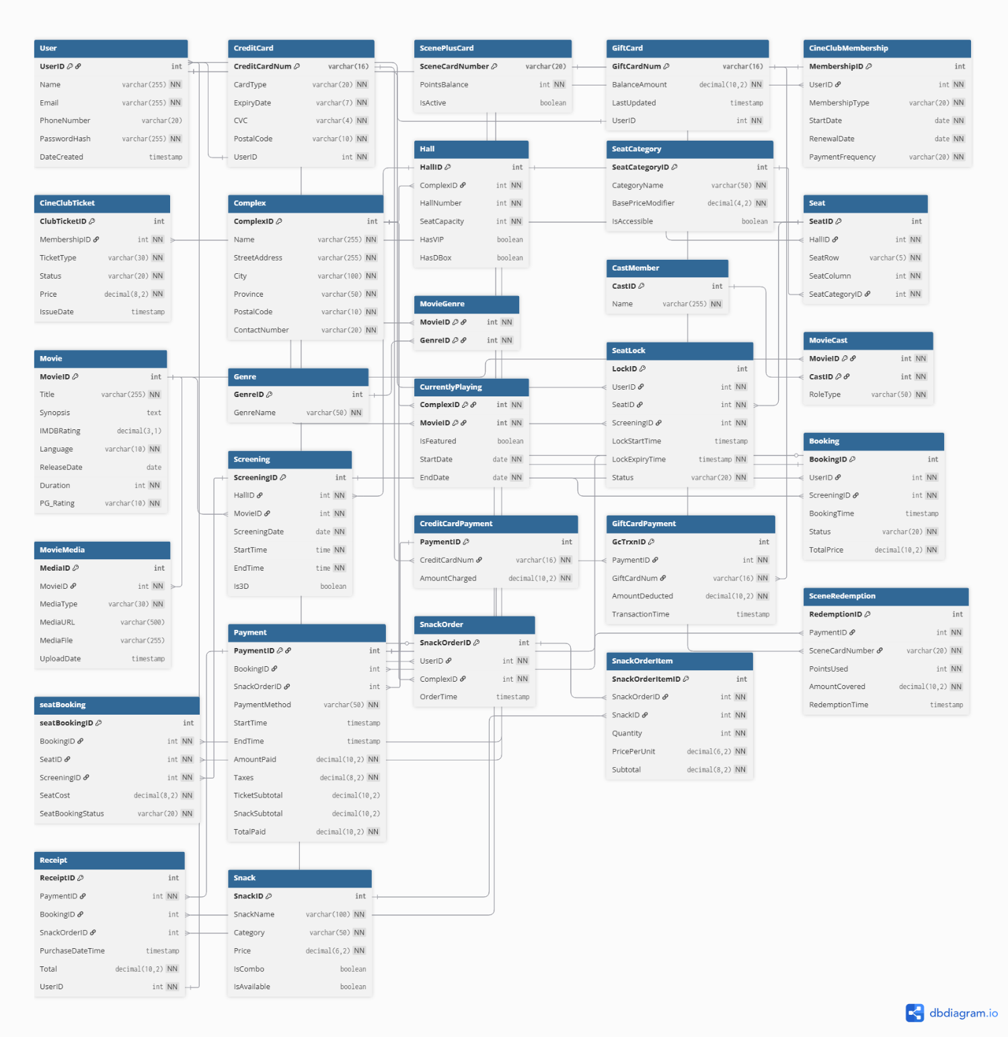

*(All diagrams of this report are available on the drive in high-resolution;* [*Click here!*](https://drive.google.com/drive/folders/1GXjMvtWV2Fs-1gmVfR1br3C4FOqhxptZ?usp=sharing)*)*

Following are the Table Creation queries for all 29 tables in the database:

*(The SQL file can be found in the drive!)*

CREATE TABLE [User] (

UserID INT PRIMARY KEY IDENTITY(1,1),

[Name] NVARCHAR(255) NOT NULL,

Email NVARCHAR(255) UNIQUE NOT NULL,

PhoneNumber NVARCHAR(20),

PasswordHash NVARCHAR(255) NOT NULL,

DateCreated DATETIME2 DEFAULT GETDATE()

);

CREATE INDEX idx_email ON [User](Email);

CREATE INDEX idx_name ON [User]([Name]);

CREATE TABLE CreditCard (

CreditCardNum NVARCHAR(16) PRIMARY KEY,

UserID INT NOT NULL,

CardType NVARCHAR(20) NOT NULL,

ExpiryDate NVARCHAR(7) NOT NULL,

CVC NVARCHAR(4) NOT NULL,

PostalCode NVARCHAR(10) NOT NULL,

CONSTRAINT FK_CreditCard_User FOREIGN KEY (UserID) REFERENCES [User](UserID) ON DELETE NO ACTION ON UPDATE NO ACTION

);

CREATE TABLE ScenePlusCard (

  SceneCardNumber NVARCHAR(20) PRIMARY KEY,

  PointsBalance INT NOT NULL DEFAULT 0 CHECK (PointsBalance >= 0),

  IsActive BIT NOT NULL DEFAULT 1

);

CREATE TABLE GiftCard (

GiftCardNum NVARCHAR(16) PRIMARY KEY,

UserID INT NOT NULL,

BalanceAmount DECIMAL(10, 2) NOT NULL CHECK (BalanceAmount >= 0),

LastUpdated DATETIME2 DEFAULT GETDATE(),

CONSTRAINT FK_GiftCard_User FOREIGN KEY (UserID) REFERENCES [User](UserID) ON DELETE NO ACTION ON UPDATE NO ACTION

);

CREATE TABLE CineClubMembership (

  MembershipID INT PRIMARY KEY IDENTITY(1,1),

  UserID INT UNIQUE NOT NULL,

  MembershipType NVARCHAR(20) NOT NULL,

  StartDate DATE NOT NULL,

  RenewalDate DATE NOT NULL,

  PaymentFrequency NVARCHAR(20) NOT NULL,

  CONSTRAINT FK_CineClubMembership_User FOREIGN KEY (UserID) REFERENCES [User](UserID) ON DELETE CASCADE ON UPDATE CASCADE

);

CREATE TABLE CineClubTicket (

  ClubTicketID INT PRIMARY KEY IDENTITY(1,1),

  MembershipID INT NOT NULL,

  TicketType NVARCHAR(30) NOT NULL,

  [Status] NVARCHAR(20) NOT NULL,

  Price DECIMAL(8, 2) NOT NULL,

  IssueDate DATETIME2 DEFAULT GETDATE(),

  CONSTRAINT FK_CineClubTicket_Membership FOREIGN KEY (MembershipID) REFERENCES CineClubMembership(MembershipID) ON DELETE CASCADE ON UPDATE CASCADE

);

CREATE TABLE [Complex] (

  ComplexID INT PRIMARY KEY IDENTITY(1,1),

  [Name] NVARCHAR(255) NOT NULL,

  StreetAddress NVARCHAR(255) NOT NULL,

  City NVARCHAR(100) NOT NULL,

  Province NVARCHAR(50) NOT NULL,

  PostalCode NVARCHAR(10) NOT NULL,

  ContactNumber NVARCHAR(20) NOT NULL

);

CREATE INDEX idx_location ON [Complex](City, Province);

CREATE TABLE Hall (

  HallID INT PRIMARY KEY IDENTITY(1,1),

  ComplexID INT NOT NULL,

  HallNumber INT NOT NULL,

  SeatCapacity INT NOT NULL CHECK (SeatCapacity > 0),

  HasVIP BIT DEFAULT 0,

  HasDBox BIT DEFAULT 0,

  CONSTRAINT FK_Hall_Complex FOREIGN KEY (ComplexID) REFERENCES [Complex](ComplexID) ON DELETE CASCADE ON UPDATE CASCADE,

  CONSTRAINT UK_Hall_Number UNIQUE (ComplexID, HallNumber)

);

CREATE TABLE SeatCategory (

  SeatCategoryID INT PRIMARY KEY IDENTITY(1,1),

  CategoryName NVARCHAR(50) UNIQUE NOT NULL,

  BasePriceModifier DECIMAL(4, 2) NOT NULL,

  IsAccessible BIT DEFAULT 0

);

CREATE TABLE Seat (

  SeatID INT PRIMARY KEY IDENTITY(1,1),

  HallID INT NOT NULL,

  SeatRow NVARCHAR(5) NOT NULL,

  SeatColumn INT NOT NULL,

  SeatCategoryID INT NOT NULL,

  CONSTRAINT FK_Seat_Hall FOREIGN KEY (HallID) REFERENCES Hall(HallID) ON DELETE CASCADE ON UPDATE CASCADE,

  CONSTRAINT FK_Seat_Category FOREIGN KEY (SeatCategoryID) REFERENCES SeatCategory(SeatCategoryID) ON DELETE NO ACTION ON UPDATE NO ACTION,

  CONSTRAINT UK_Seat_Location UNIQUE (HallID, SeatRow, SeatColumn)

);

CREATE TABLE Movie (

  MovieID INT PRIMARY KEY IDENTITY(1,1),

  Title NVARCHAR(255) NOT NULL,

  Synopsis NVARCHAR(MAX),

  IMDBRating DECIMAL(3, 1),

  [Language] NVARCHAR(10) NOT NULL,

  ReleaseDate DATE,

  Duration INT NOT NULL CHECK (Duration > 0),

  PG_Rating NVARCHAR(10) NOT NULL

);

CREATE TABLE [Genre] (

  GenreID INT PRIMARY KEY IDENTITY(1,1),

  GenreName NVARCHAR(50) UNIQUE NOT NULL

);

CREATE TABLE MovieGenre (

  MovieID INT NOT NULL,

  GenreID INT NOT NULL,

  PRIMARY KEY (MovieID, GenreID),

  CONSTRAINT FK_MovieGenre_Movie FOREIGN KEY (MovieID) REFERENCES Movie(MovieID) ON DELETE CASCADE ON UPDATE CASCADE,

  CONSTRAINT FK_MovieGenre_Genre FOREIGN KEY (GenreID) REFERENCES [Genre](GenreID) ON DELETE CASCADE ON UPDATE CASCADE

);

CREATE TABLE CastMember (

  CastID INT PRIMARY KEY IDENTITY(1,1),

  [Name] NVARCHAR(255) NOT NULL

);

CREATE TABLE MovieCast (

  MovieID INT NOT NULL,

  CastID INT NOT NULL,

  RoleType NVARCHAR(50) NOT NULL,

  PRIMARY KEY (MovieID, CastID),

  CONSTRAINT FK_MovieCast_Movie FOREIGN KEY (MovieID) REFERENCES Movie(MovieID) ON DELETE CASCADE ON UPDATE CASCADE,

  CONSTRAINT FK_MovieCast_Cast FOREIGN KEY (CastID) REFERENCES CastMember(CastID) ON DELETE CASCADE ON UPDATE CASCADE

);

CREATE TABLE MovieMedia (

  MediaID INT PRIMARY KEY IDENTITY(1,1),

  MovieID INT NOT NULL,

  MediaType NVARCHAR(30) NOT NULL,

  MediaURL NVARCHAR(500),

  MediaFile NVARCHAR(255),

  UploadDate DATETIME2 DEFAULT GETDATE(),

  CONSTRAINT FK_MovieMedia_Movie FOREIGN KEY (MovieID) REFERENCES Movie(MovieID) ON DELETE CASCADE ON UPDATE CASCADE

);

CREATE TABLE Screening (

  ScreeningID INT PRIMARY KEY IDENTITY(1,1),

  HallID INT NOT NULL,

  MovieID INT NOT NULL,

  ScreeningDate DATE NOT NULL,

  StartTime TIME NOT NULL,

  EndTime TIME NOT NULL,

  Is3D BIT DEFAULT 0,

  CONSTRAINT FK_Screening_Hall FOREIGN KEY (HallID) REFERENCES Hall(HallID) ON DELETE NO ACTION ON UPDATE NO ACTION,

  CONSTRAINT FK_Screening_Movie FOREIGN KEY (MovieID) REFERENCES Movie(MovieID) ON DELETE NO ACTION ON UPDATE NO ACTION,

  CONSTRAINT CHK_Screening_Times CHECK (StartTime < EndTime)

);

CREATE INDEX idx_screening_schedule ON Screening(HallID, ScreeningDate, StartTime);

CREATE TABLE CurrentlyPlaying (

  ComplexID INT NOT NULL,

  MovieID INT NOT NULL,

  IsFeatured BIT DEFAULT 0,

  StartDate DATE NOT NULL,

  EndDate DATE NOT NULL,

  PRIMARY KEY (ComplexID, MovieID),

  CONSTRAINT FK_CurrentlyPlaying_Complex FOREIGN KEY (ComplexID) REFERENCES [Complex](ComplexID) ON DELETE CASCADE ON UPDATE CASCADE,

  CONSTRAINT FK_CurrentlyPlaying_Movie FOREIGN KEY (MovieID) REFERENCES Movie(MovieID) ON DELETE CASCADE ON UPDATE CASCADE,

  CONSTRAINT CHK_Playing_Dates CHECK (EndDate >= StartDate)

);

CREATE TABLE SeatLock (

  LockID INT PRIMARY KEY IDENTITY(1,1),

  UserID INT NOT NULL,

  SeatID INT NOT NULL,

  ScreeningID INT NOT NULL,

  LockStartTime DATETIME2 DEFAULT GETDATE(),

  LockExpiryTime DATETIME2 NOT NULL,

  [Status] NVARCHAR(20) NOT NULL,

  CONSTRAINT FK_SeatLock_User FOREIGN KEY (UserID) REFERENCES [User](UserID) ON DELETE CASCADE ON UPDATE CASCADE,

  CONSTRAINT FK_SeatLock_Seat FOREIGN KEY (SeatID) REFERENCES Seat(SeatID) ON DELETE NO ACTION ON UPDATE NO ACTION,

  CONSTRAINT FK_SeatLock_Screening FOREIGN KEY (ScreeningID) REFERENCES Screening(ScreeningID) ON DELETE NO ACTION ON UPDATE NO ACTION,

  CONSTRAINT CHK_Lock_Expiry CHECK (LockExpiryTime > LockStartTime)

);

CREATE INDEX idx_seat_screening ON SeatLock(SeatID, ScreeningID);

CREATE TABLE Booking (

  BookingID INT PRIMARY KEY IDENTITY(1,1),

  UserID INT NOT NULL,

  ScreeningID INT NOT NULL,

  BookingTime DATETIME2 DEFAULT GETDATE(),

  [Status] NVARCHAR(20) NOT NULL,

  TotalPrice DECIMAL(10, 2) NOT NULL CHECK (TotalPrice >= 0),

  CONSTRAINT FK_Booking_User FOREIGN KEY (UserID) REFERENCES [User](UserID) ON DELETE CASCADE ON UPDATE CASCADE,

  CONSTRAINT FK_Booking_Screening FOREIGN KEY (ScreeningID) REFERENCES Screening(ScreeningID) ON DELETE NO ACTION ON UPDATE NO ACTION

);

CREATE INDEX idx_user_booking ON Booking(UserID, ScreeningID);

CREATE TABLE seatBooking (

  seatBookingID INT PRIMARY KEY IDENTITY(1,1),

  BookingID INT NOT NULL,

  SeatID INT NOT NULL,

  ScreeningID INT NOT NULL,

  SeatCost DECIMAL(8, 2) NOT NULL CHECK (SeatCost >= 0),

  SeatBookingStatus NVARCHAR(20) NOT NULL,

  CONSTRAINT FK_SeatBooking_Booking FOREIGN KEY (BookingID) REFERENCES Booking(BookingID) ON DELETE CASCADE ON UPDATE CASCADE,

  CONSTRAINT FK_SeatBooking_Seat FOREIGN KEY (SeatID) REFERENCES Seat(SeatID) ON DELETE NO ACTION ON UPDATE NO ACTION,

  CONSTRAINT FK_SeatBooking_Screening FOREIGN KEY (ScreeningID) REFERENCES Screening(ScreeningID) ON DELETE NO ACTION ON UPDATE NO ACTION

);

CREATE INDEX idx_booking_seat ON seatBooking(BookingID, SeatID);

CREATE TABLE Snack (

  SnackID INT PRIMARY KEY IDENTITY(1,1),

  SnackName NVARCHAR(100) NOT NULL,

  Category NVARCHAR(50) NOT NULL,

  Price DECIMAL(6, 2) NOT NULL CHECK (Price > 0),

  IsCombo BIT DEFAULT 0,

  IsAvailable BIT DEFAULT 1

);

CREATE TABLE SnackOrder (

  SnackOrderID INT PRIMARY KEY IDENTITY(1,1),

  UserID INT NOT NULL,

  ComplexID INT NOT NULL,

  OrderTime DATETIME2 DEFAULT GETDATE(),

  CONSTRAINT FK_SnackOrder_User FOREIGN KEY (UserID) REFERENCES [User](UserID) ON DELETE CASCADE ON UPDATE CASCADE,

  CONSTRAINT FK_SnackOrder_Complex FOREIGN KEY (ComplexID) REFERENCES [Complex](ComplexID) ON DELETE NO ACTION ON UPDATE NO ACTION

);

CREATE TABLE SnackOrderItem (

  SnackOrderItemID INT PRIMARY KEY IDENTITY(1,1),

  SnackOrderID INT NOT NULL,

  SnackID INT NOT NULL,

  Quantity INT NOT NULL CHECK (Quantity > 0),

  PricePerUnit DECIMAL(6, 2) NOT NULL CHECK (PricePerUnit > 0),

  Subtotal DECIMAL(8, 2) NOT NULL CHECK (Subtotal > 0),

  CONSTRAINT FK_SnackOrderItem_Order FOREIGN KEY (SnackOrderID) REFERENCES SnackOrder(SnackOrderID) ON DELETE CASCADE ON UPDATE CASCADE,

  CONSTRAINT FK_SnackOrderItem_Snack FOREIGN KEY (SnackID) REFERENCES Snack(SnackID) ON DELETE NO ACTION ON UPDATE NO ACTION

);

CREATE TABLE [Payment] (

  PaymentID INT PRIMARY KEY IDENTITY(1,1),

  BookingID INT,

  SnackOrderID INT,

  PaymentMethod NVARCHAR(50) NOT NULL,

  StartTime DATETIME2 DEFAULT GETDATE(),

  EndTime DATETIME2,

  AmountPaid DECIMAL(10, 2) NOT NULL CHECK (AmountPaid >= 0),

  Taxes DECIMAL(8, 2) NOT NULL CHECK (Taxes >= 0),

  TicketSubtotal DECIMAL(10, 2),

  SnackSubtotal DECIMAL(10, 2),

  TotalPaid DECIMAL(10, 2) NOT NULL CHECK (TotalPaid >= 0),

  CONSTRAINT CHK_Payment_Link CHECK (BookingID IS NOT NULL OR SnackOrderID IS NOT NULL),

  CONSTRAINT CHK_Total_Paid CHECK (TotalPaid = ISNULL(TicketSubtotal, 0) + ISNULL(SnackSubtotal, 0) + Taxes),

  CONSTRAINT FK_Payment_Booking FOREIGN KEY (BookingID) REFERENCES Booking(BookingID) ON DELETE NO ACTION ON UPDATE NO ACTION,

  CONSTRAINT FK_Payment_SnackOrder FOREIGN KEY (SnackOrderID) REFERENCES SnackOrder(SnackOrderID) ON DELETE NO ACTION ON UPDATE NO ACTION

);

CREATE INDEX idx_payment_booking ON [Payment](BookingID);

CREATE INDEX idx_payment_snack ON [Payment](SnackOrderID);

CREATE TABLE CreditCardPayment (

  PaymentID INT PRIMARY KEY,

  CreditCardNum NVARCHAR(16) NOT NULL,

  AmountCharged DECIMAL(10, 2) NOT NULL CHECK (AmountCharged > 0),

  CONSTRAINT FK_CreditCardPayment_Payment FOREIGN KEY (PaymentID) REFERENCES [Payment](PaymentID) ON DELETE CASCADE ON UPDATE CASCADE,

  CONSTRAINT FK_CreditCardPayment_Card FOREIGN KEY (CreditCardNum) REFERENCES CreditCard(CreditCardNum) ON DELETE NO ACTION ON UPDATE NO ACTION

);

CREATE TABLE GiftCardPayment (

  GcTrxnID INT PRIMARY KEY IDENTITY(1,1),

  PaymentID INT NOT NULL,

  GiftCardNum NVARCHAR(16) NOT NULL,

  AmountDeducted DECIMAL(10, 2) NOT NULL CHECK (AmountDeducted > 0),

  TransactionTime DATETIME2 DEFAULT GETDATE(),

  CONSTRAINT FK_GiftCardPayment_Payment FOREIGN KEY (PaymentID) REFERENCES [Payment](PaymentID) ON DELETE NO ACTION ON UPDATE NO ACTION,

  CONSTRAINT FK_GiftCardPayment_Card FOREIGN KEY (GiftCardNum) REFERENCES GiftCard(GiftCardNum) ON DELETE NO ACTION ON UPDATE NO ACTION

);

CREATE TABLE SceneRedemption (

  RedemptionID INT PRIMARY KEY IDENTITY(1,1),

  PaymentID INT NOT NULL,

  SceneCardNumber NVARCHAR(20) NOT NULL,

  PointsUsed INT NOT NULL CHECK (PointsUsed > 0),

  AmountCovered DECIMAL(10, 2) NOT NULL CHECK (AmountCovered > 0),

  RedemptionTime DATETIME2 DEFAULT GETDATE(),

  CONSTRAINT FK_SceneRedemption_Payment FOREIGN KEY (PaymentID) REFERENCES [Payment](PaymentID) ON DELETE NO ACTION ON UPDATE NO ACTION,

  CONSTRAINT FK_SceneRedemption_Card FOREIGN KEY (SceneCardNumber) REFERENCES ScenePlusCard(SceneCardNumber) ON DELETE NO ACTION ON UPDATE NO ACTION

);

CREATE TABLE Receipt (

ReceiptID INT PRIMARY KEY IDENTITY(1,1),

PaymentID INT UNIQUE NOT NULL,

UserID INT NOT NULL,

BookingID INT,

SnackOrderID INT,

PurchaseDateTime DATETIME2 DEFAULT GETDATE(),

Total DECIMAL(10, 2) NOT NULL CHECK (Total >= 0),

CONSTRAINT FK_Receipt_Payment FOREIGN KEY (PaymentID) REFERENCES [Payment](PaymentID) ON DELETE NO ACTION ON UPDATE NO ACTION,

CONSTRAINT FK_Receipt_User FOREIGN KEY (UserID) REFERENCES [User](UserID) ON DELETE NO ACTION ON UPDATE NO ACTION,

CONSTRAINT FK_Receipt_Booking FOREIGN KEY (BookingID) REFERENCES Booking(BookingID) ON DELETE NO ACTION ON UPDATE NO ACTION,

CONSTRAINT FK_Receipt_SnackOrder FOREIGN KEY (SnackOrderID) REFERENCES SnackOrder(SnackOrderID) ON DELETE NO ACTION ON UPDATE NO ACTION

);

CREATE INDEX idx_user_email ON [User](Email);

CREATE INDEX idx_booking_user_date ON Booking(UserID, BookingTime);

CREATE INDEX idx_seat_booking_status ON seatBooking(SeatBookingStatus);

CREATE INDEX idx_seat_lock_expiry ON SeatLock(LockExpiryTime);

CREATE INDEX idx_movie_title ON Movie(Title);

CREATE INDEX idx_movie_genre ON MovieGenre(GenreID);

CREATE INDEX idx_screening_movie ON Screening(MovieID);

CREATE INDEX idx_payment_method ON [Payment](PaymentMethod);

CREATE INDEX idx_payment_time ON [Payment](StartTime);

CREATE INDEX idx_snack_order_user ON SnackOrder(UserID);

CREATE INDEX idx_snack_order_complex ON SnackOrder(ComplexID);

**Entity Integrity**

Entity integrity ensures that each table in the database maintains a unique identifier for every record, and that no component of the primary key can be null. In our database design, we ensured entity integrity by rigorously assigning primary keys to every table and, where appropriate, using composite primary keys to model M:N relationships or context-specific uniqueness.

Examples of Composite Primary Keys in Our Design:

|  |  |
| --- | --- |
| Table Name | Composite Key Field |
| BookingSeat | bookingID, seatID |
| SceneRedemption | SceneCardNumber, redemptionID |
| GiftCardPayment | GiftCardNum, paymentID |
| SnackOrderItem | snackOrderID, snackID |

By applying these keys, we ensure that each record remains uniquely identifiable and prevents insertion of null values in primary key columns. For example, in the SnackOrderItem table, each snack item is uniquely tied to a specific order, avoiding any accidental duplication.

**Domain Integrity**

Domain integrity restricts attribute values to valid, meaningful, and defined formats. In our database, we enforced domain integrity by specifying:

* Appropriate data types (INT, VARCHAR, DECIMAL, DATE, etc.)
* NOT NULL constraints to ensure mandatory data
* CHECK constraints to enforce logical validity
* UNIQUE constraints for distinct attributes (like email)

|  |  |  |
| --- | --- | --- |
| Attribute | Constraint(s) | Description |
| email (User) | VARCHAR(100), NOT NULL | Valid format required |
| paymentMethod (Payment) | ENUM or VARCHAR, NOT NULL | Restricts values to defined payment modes |
| basePriceModifier | DECIMAL(4,2), CHECK (value > 0) | Prevents illogical seat pricing modifiers |
| quantity (SnackOrderItem) | INT, CHECK (quantity >= 1) | Avoids invalid snack order quantities |

**Referential Integrity**

Referential integrity guarantees consistency in relationships between tables. It requires that every foreign key either matches an existing primary key in the referenced table or is set to NULL when the relationship is optional.

In our design, we applied foreign keys throughout and used actions like ON DELETE CASCADE or SET NULL, depending on the business logic, to ensure data integrity.

**Examples:**

|  |  |  |  |
| --- | --- | --- | --- |
| Foreign Key (FK) | References (PK) | ON DELETE Action | Description |
| userID in Booking | User(userID) | CASCADE | Bookings tied to valid users |
| paymentID in Receipt | Payment(paymentID) | CASCADE | Ensures summary always tied to payment |
| seatID in seatBooking | Seat(seatID) | CASCADE | Validates assigned seats exist |
| snackOrderID in SnackOrderItem | SnackOrder(snackOrderID) | CASCADE | Validates items tied to existing orders |
| sceneCardNumber in SceneRedemption | ScenePlusCard(sceneCardNum) | SET NULL | Optional linkage to loyalty program |

We ensured that optional relationships such as GiftCardPayment to Payment, or SceneRedemption to a Scene card, allow NULLs to reflect real-world optionality.

**Sample Data for All the Tables**

Genre Table:

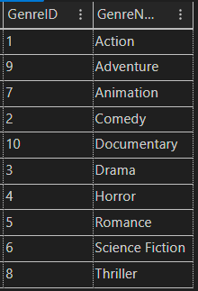

SeatCategory Table:

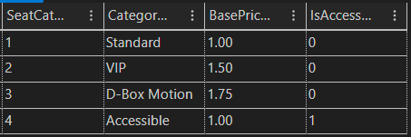

CastMember Table:

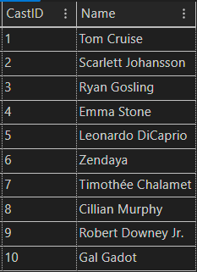

Snack Table:

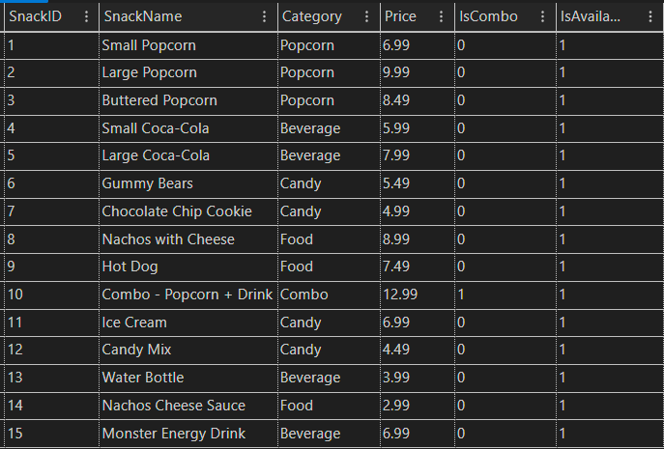

User Table:

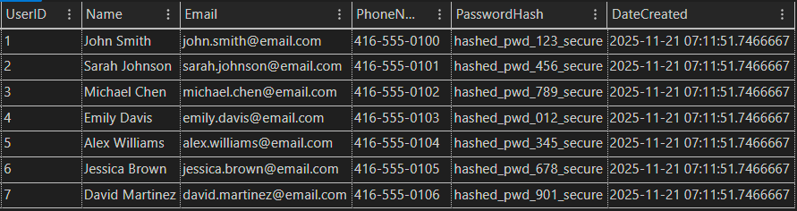

CreditCard Table:

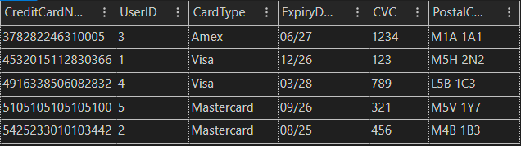

GiftCard Table:

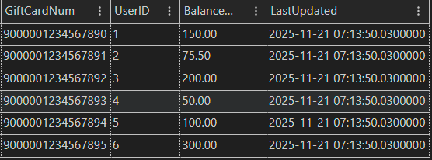

Movie Table;

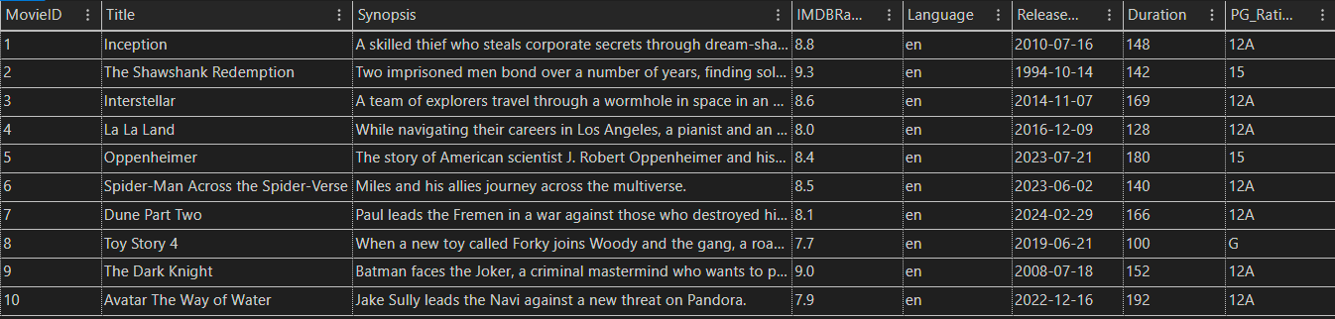

MovieGenre Table:

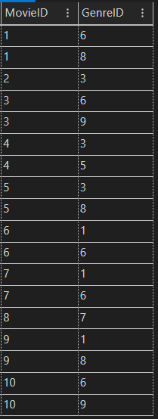

MovieCast Table:

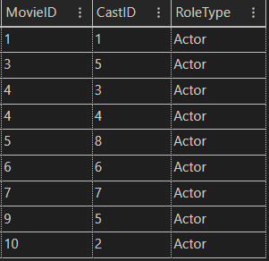

MovieMedia Table: *(mediaFile column empty because we don’t have movies downloaded)*

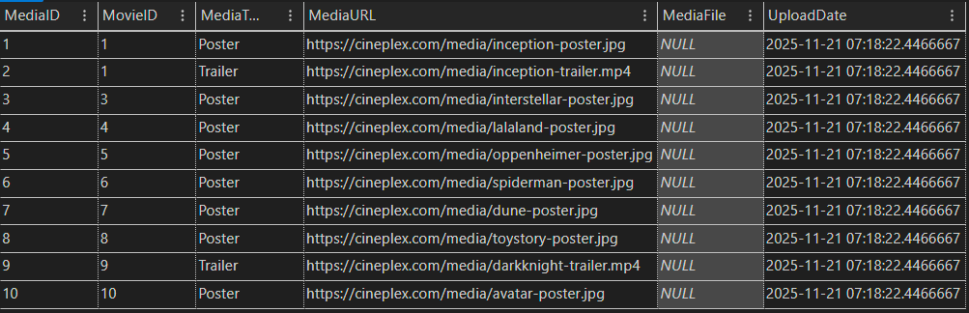

ScenePlusCard Table:

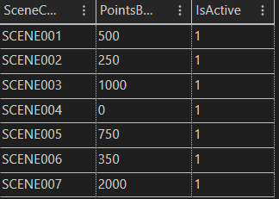

CineClubMembership Table:  
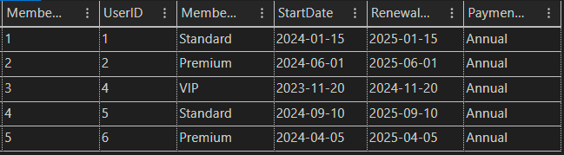

CineClubTicket Table:

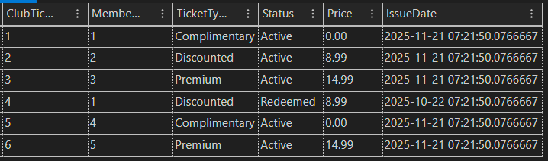

Complex Table:

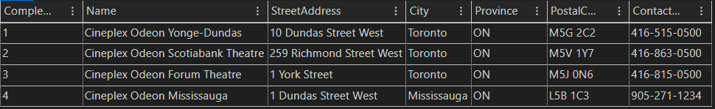

Hall Table:  
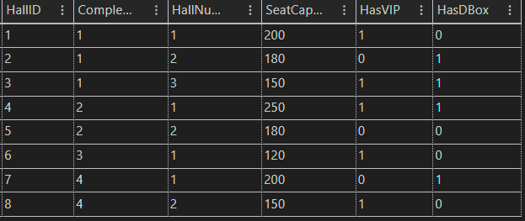

Seat Table:

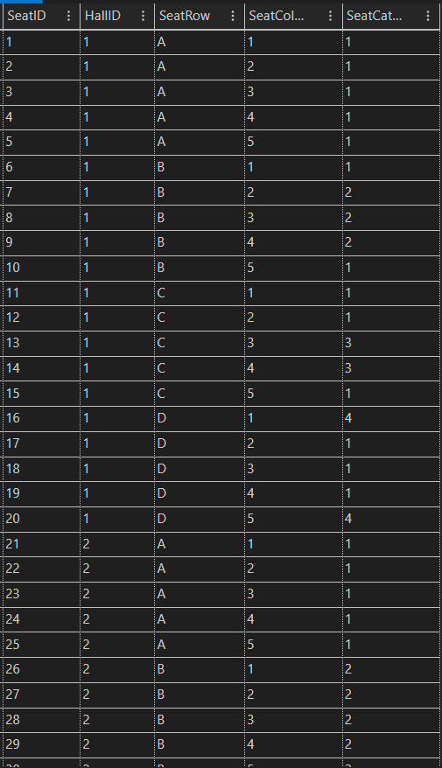

Screening Table:

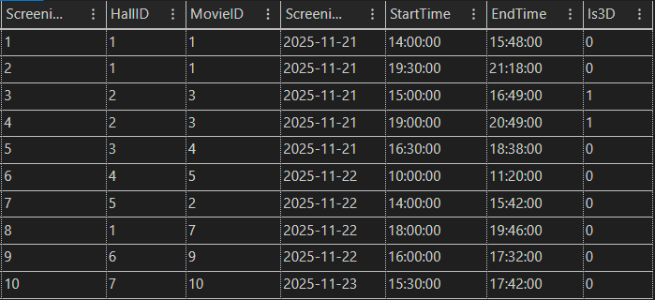

CurrentlyPlaying Table:  
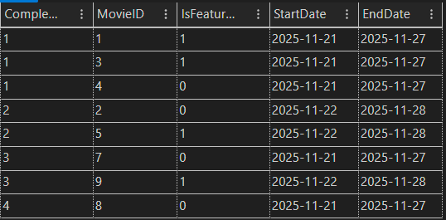

SeatLock Table:  
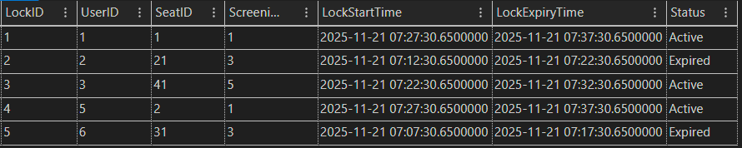

Booking Table:

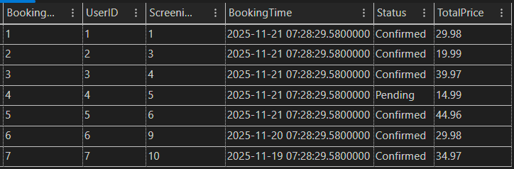

seatBooking Table:

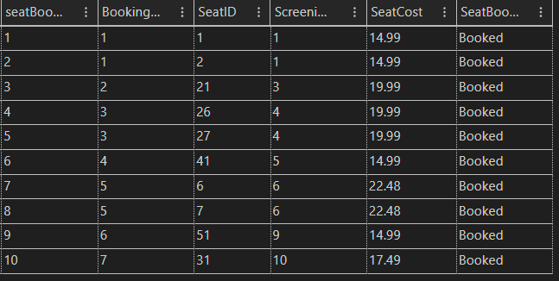

SnackOrder Table:

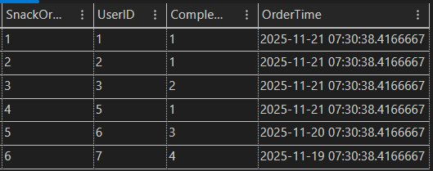

SnackOrderItem Table:

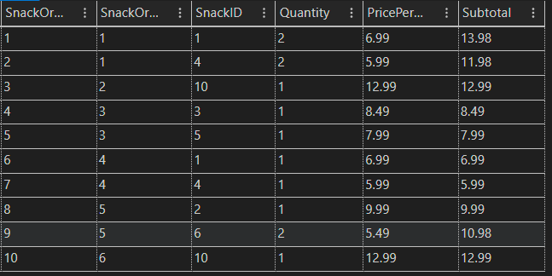

Payment Table:  
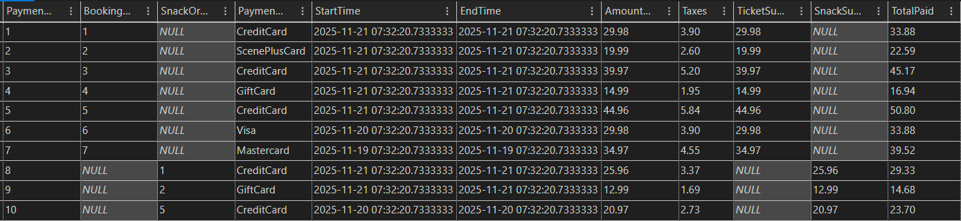

CreditCardPayment Table:

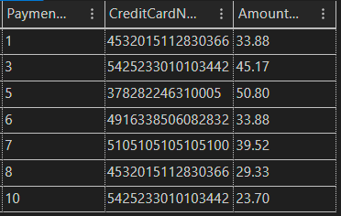

GiftCardPayment Table:  
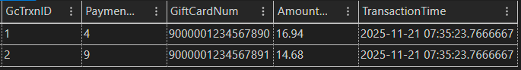

SceneRedemption Table:

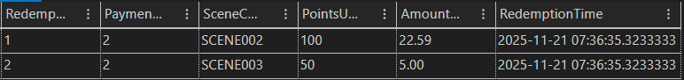

Receipt Table:

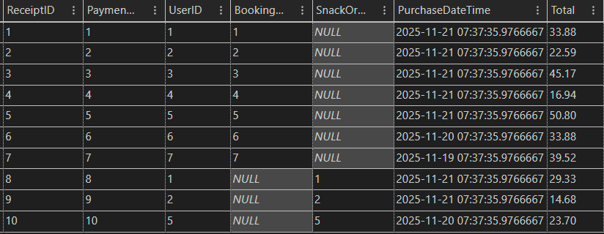

**Sample SQL queries to support applications and reports for management use.**

**Query 1 - Revenue by Payment Method**

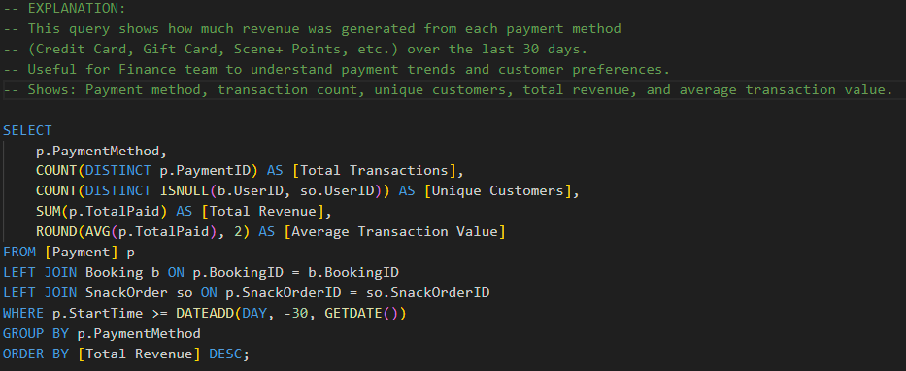

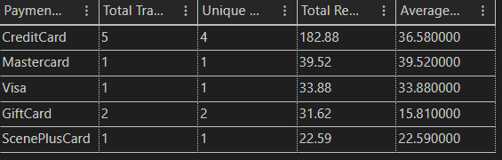

**Query 2 - Top 10 Movies by Box Office**

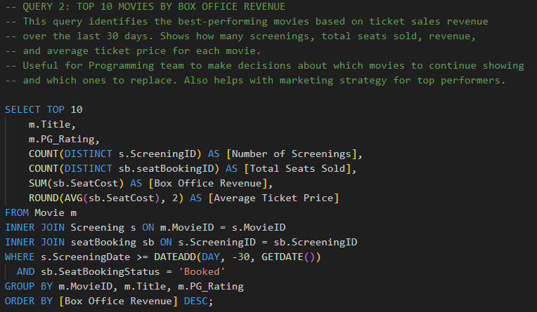

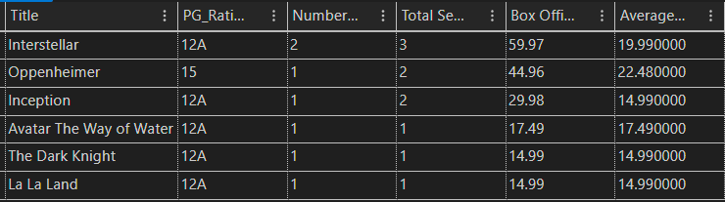

**Query 3 - Top 10 Customers by Spending**

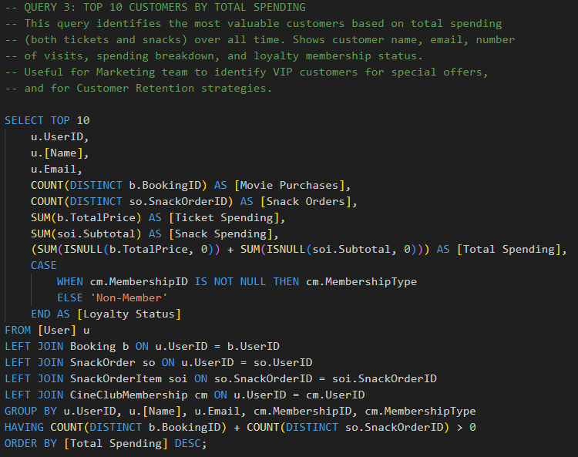

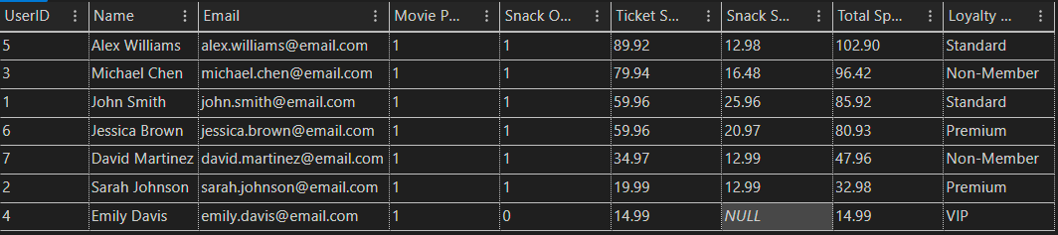

**Query 4 - Seat Occupancy by Screening**

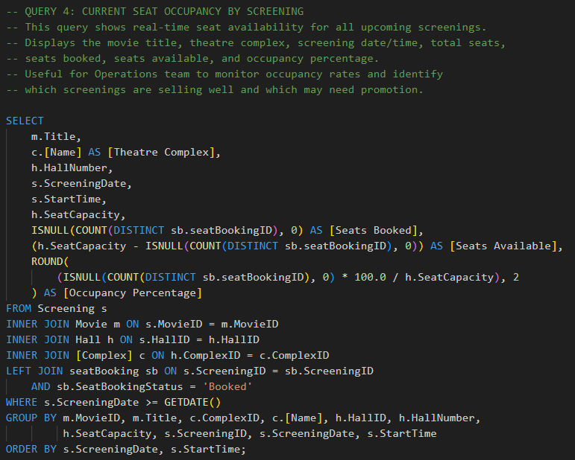

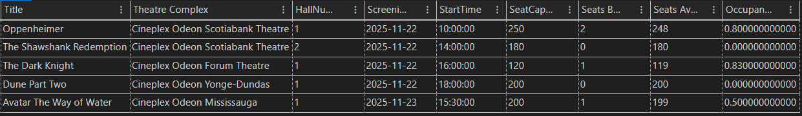

**Query 5 - Top 10 Snacks by Revenue**

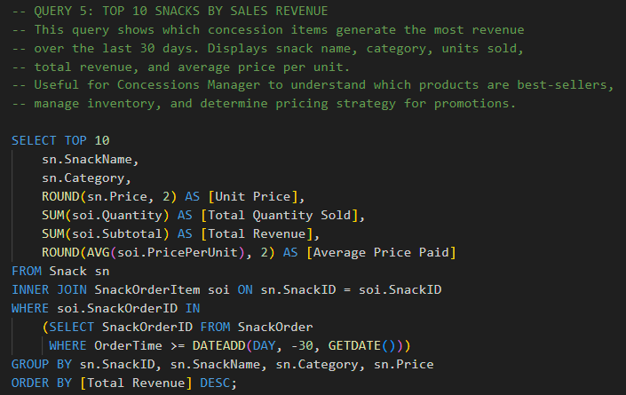

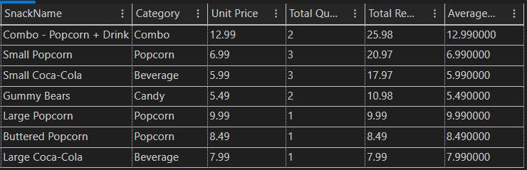

**Evaluation and Conclusion**

**The Achievement of the Project**

Our project successfully designed and implemented a comprehensive relational database system for Cineplex, capturing the full complexity of cinema operations including user management, bookings, payments, loyalty, and sales analytics. Our team produced a normalized, scalable schema with 29 interrelated tables, ensuring strong data integrity and referential consistency. Key deliverables included robust table creation scripts, full sample data population, and business-focused SQL queries for real-time management reporting. The project meets, course requirements by providing both technical correctness and practical application value, supporting all essential business processes for a large multi-theatre cinema chain.

**Further Development and Improvement**

Future enhancements can focus on stored procedures for transaction workflows such as booking, payment, and receipt issuance, as well as implementation of database views for simplified reporting. Introducing advanced analytics, such as customer segmentation and dynamic ticket pricing, would add strategic value. Security could be elevated with user roles and audit logging. In the long term, separating transactional and analytical workloads into OLAP and OLTP systems, plus adding support for mobile and multi-language functionality, would make the system more robust and adaptable for potential expansion or integration with other business platforms.

**Advantages and Limitations of the Database Package Used**

Microsoft SQL Server offers robust support for relational integrity, advanced data types, indexing, transaction management, and compatibility with industry-standard BI tools. Its integrated development environment simplifies schema creation, debugging, and backup. However, SQL Server restricts multiple cascading actions across relationships, occasionally requiring workaround designs (e.g., ON DELETE NO ACTION), and its licensing costs may not be ideal for small-scale or open-source projects. Performance can also be resource-intensive as data volumes grow. Despite these limitations, it remains a reliable, well-documented choice for medium to large enterprise database solutions.

**The Experience Learned from This Project**

This project provided us with hands-on experience of every phase of database development: conceptual modeling, normalization, schema implementation, integrity enforcement, and real-world SQL coding. Dealing with relationship complexity and constraint management in SQL Server reinforced the importance of proper planning, testing, and clear documentation. Collaborative teamwork allowed for effective role distribution and mutual feedback. The process also highlighted the need for iterative design, resolving issues such as foreign key loops and identity constraints refined both technical skills and project management competencies, equipping the team for future, larger-scale database projects.

**Contribution by Each Team Member**

1. **Mohammad Areeb (220094736)**
   * Led database design, normalization, and schema creation.
   * Developed and refined the ER model.
   * Implemented all SQL table scripts, sample data, queries, and integrity controls.
   * Authored the complete project proposal and progress report.
   * Coordinated final report writing and resolved major design issues.
2. **Prabhkrit Singh (220164059)**
   * Supported ER model development and refinement.
   * Assisted with report drafting and ERD documentation.
   * Provided feedback on schema and relationships.
3. **Samarjeet Singh Arora (220857686)**
   * Participated in ER model drafting.
   * Assisted with attribute validation and relationship mapping.
4. **Akash Deep (220854162)**
   * Helped in initial ER model design, relationships, and attribute definition.
   * Supported final report preparation and conceptual design.
5. **Karthikeya Gorijavolu (220241030)**
   * Wrote background and objectives.
   * Provided business context.

**Note:**

* All members contributed to team meetings and review sessions.
* Key technical leadership, major documentation (including proposal and progress report), and overall project integration were led by Mohammad Areeb, supported by effective collaboration from all members.